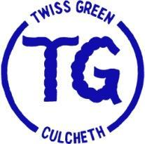

Twiss Green
Community Primary School

Science Policy
Sept 2022 - Sept 2023
Date of Approval: | January 2023
Signed: Headteacher | N. Hughes
To be reviewed by: | September 2023

Contents
- Principle
2. Intent
3. Implementation
4. Appendix

Policy for Science
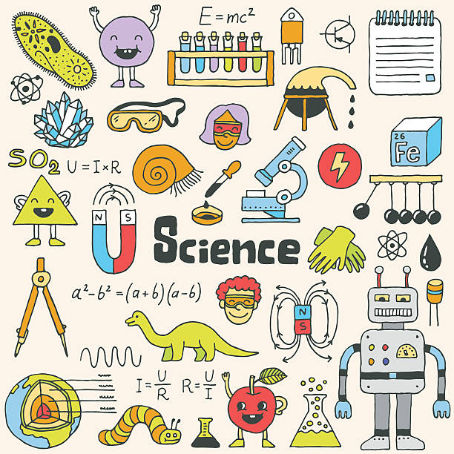

PRINCIPLE

Children at Twiss Green develop scientific knowledge, skills and understanding, through an enquiry based approach.

INTENT

- To provide purposeful activities and creative approaches to develop essential scientific skills and knowledge.
- To promote an attitude of learning centred on enquiry and engagement.
- To aid children's cognitive development and thinking skills.
- To deepen understanding of how to keep healthy and respect the environment.
- We aim for the children to know more, remember more and understand more about Science.

IMPLEMENTATION
Inclusion
In accordance with the school’s SEND Policy, Science activities/work is differentiated to meet the needs of each pupil. However, as per Ofsted’s School Inspection Handbook (2022), the curriculum will not be slimmed down; ‘More Able’ pupils and SEND children will be identified through a range of activities so that they can be challenged further and/or their barriers removed to enable access to the Science curriculum. Children will often work in mixed ability ‘teams’ and have the opportunity to work as part of a class, individually and other groupings.
Equality and ‘Science Capital’
Teachers will ensure that all pupils have fair access to the Science curriculum, regardless of gender, race, or ability, in accordance with the school’s Equality Policy.
In order to build our children's Science Capital, we aim to study more contemporary and diverse scientists from various backgrounds and cultures and also celebrate International Women & Girls in Science Day.
Science Adventures! Set in the half term of National Science Week, this is an opportunity to explore, enrich and deepen the understanding of the topics studied so far. Real scientists (which often includes some of our parents) will be invited into school to ensure strong links to the real world and how science is used and applied. Children will explore skills in more depth in order to support their use across the rest of the academic year.
Science lessons
We develop our units and lessons using our Science Knowledge Progression document (available to download on the website), which was created using PLAN Assessment documents.
Science lessons begin with, where appropriate, a ‘Hook’ to provoke children’s curiosity and to get them thinking and reasoning in different ways.
Wherever possible, we use our beautiful grounds to explore and teach Science and use recommended best practice online resources to support learning in the classroom. Much of the Science work should be practical, using a wide range of equipment, including IT&C where beneficial.
Science books & Displays/Working Walls
Children communicate their scientific findings, through both the written and the spoken word, in an increasingly formalised manner, as they progress through the school.
With the exception of Reception class, who produce a floor book, Science books should have a consistent appearance across the school. In our Science books are:
- TG Marking Code
- TG Knowledge and Working Scientifically Organiser
- Following an underlined date an enquiry question, there will be various presentations to show work including photographs, diagrams on plain paper, and tables (see below for guidance on expectations for producing tables to record data)
- TAPS Assessments (Teacher Assessment in Primary Science) for Working Scientifically
The Primary Science Teaching Trust (PSTT) - Whole-School Approach
‘… if children are recording data in a table:
• With children (ages 5-7), you might model how to use a pre-prepared table with column headings to record observations before you ask children to do this independently.
• With children (ages 7-9), you might provide a table (with or without column headings) for children to record their observations.
• With children (ages 9-11), you might expect children to draw their own table with appropriate column headings to record their findings (including for repeat readings and averages).’

Science displays to include the following features:
- Sequence of learning/Enquiry Questions
- Examples of work/children’s work
- Photos of children
- Working Scientifically ‘Post-It’ planning boards
- Vocabulary

See appendix for examples of class displays.

Curriculum
Our curriculum has been developed using the DFE’s recommended best-practice PLAN Assessment materials and TAPS assessments alongside the National Curriculum to aid the teacher assessment of the substantive (knowledge) and disciplinary skills (Working Scientifically). This document shows prior learning, common misconceptions and future learning to heavily support planning and progression. To develop ‘sticky knowledge’, each unit of work begins with a ‘Can I still remember…?’ task.
Reading
To encourage wider reading, teachers should display books in their classrooms about their current unit. These can be found in the nurture room’s cupboards.
Resources
All teachers have access to resources in 2 separate Science cupboards. The trays inside contain resources for the various units.
Use of IT&C
To support and develop learning around collecting and presenting data, we use data loggers, graphs on Purple Mash and Google Sheets in Years 5 & 6 who now use Chromebooks.
Assessment & Recording
Assessment for Learning techniques should underpin teaching and learning. Teachers will use the TAPS Pyramid to support assessment in knowledge and the TAPS assessments for Working Scientifically - once per topic. The results of these assessments will then be recorded on Insight Tracking.
Health & Safety
Teachers should have read CLEAPSS: ‘Health and Safety in Primary Science and Technology’, and all sessions should follow safety guidelines.
Rewritten September 2022 L. Milward

- Appendix
