Year Five Curriculum Map 2023-24
 | Autumn 1 | Autumn 2 | Spring 1 | Spring 2 |  | Summer 1 | Summer 2
Vehicle Text | 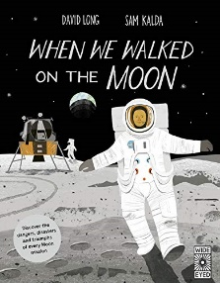  When We Walked on the Moon | FArTHER  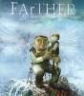 | The Hound of the Baskervilles  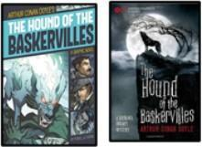 | The Promise  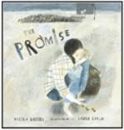 |  | The Lost Book of Adventure  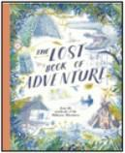 | King Kong  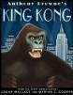
English: Writing Outcome & Purposes | Narrative –  Exploration Narrative Recount – Formal Mission Log | Narrative - Setting Narrative  Recount - Letter | Narrative - Cliff-hanger Narrative  Inform – Formal Event Report |  | Narrative -  Character Narrative  Recount-  Newspaper Report | Narrative – Survival Narrative Explanation-  Survival Guide | Narrative - Dilemma Narrative  Discussion- Balanced Argument
Whole Class Reading | 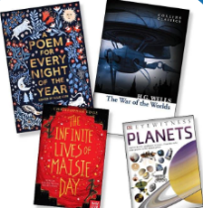  Science: Space | 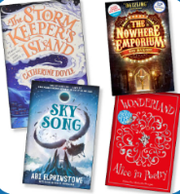  Additional 2-week Science unit: Forces  Reading Breadth  Stories & Poetry – | 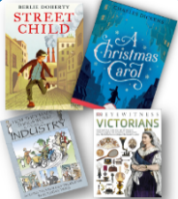  History:  Victorians | 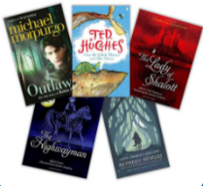  Reading Breadth: Myths & Legends and Plays & Poetry – wider range |  | 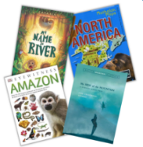  Reading Breadth: Stories from other Cultures and  Traditions | 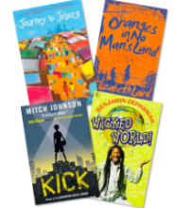  Geography: North & South America/ World
 |  | different forms
Maths | Number – Place Value  Number – Addition, Subtraction, Multiplication and Division | Number – Addition, Subtraction, Multiplication and Division  Number: Fractions | Number –Multiplication and Division  Number: Fractions | Number – Decimals and Percentages  Measurement: Perimeter and Area  Statistics |  | Geometry –  Shape  Geometry – Position and Direction  Number - Decimals | Number – Negative Numbers  Measurement – Converting Units  Measurement – Volume

Science | Earth and Space | Forces | Properties and changes of materials |  | Living Things and their Habitats | Animals including Humans
History | Were the Anglo Saxons mightier than the Vikings? |  |  | Why should we study the Maya?

Geography | Maps, atlases, globes, digital mapping, 8 points of a compass, 4 & 6 figure grid references and field work to be covered throughout the year.
 |  | Settlements | Local Geography Focus (sustainability) |  | North America
Computing Purple  Mash | Unit 5.2 Online Safety  Unit 4.1 Coding (revisit) |  | Unit 5.8 Word or Google Doc processing |  | Unit 5.1 Coding  Unit 5.6 3-D Modelling
Art |  | Sculpture and 3D:  Interactive Installation |  | Drawing:  I Need Space |  | Painting and Mixed Media: Portraits
DT | Electrical Systems: Doodlers |  | Mechanical Systems: Making a pop-up book |  | Cooking and Nutrition: What could be healthier?
PE - swimming will need to be added | Gymnastics  Net and Wall  Games- Badminton | Dance  Invasion Games- Handball | Striking & Fielding- Cricket Cheshire Cricket*  Swimming | Invasion Games Netball  Target Games Dodgeball | Invasion Game- Tag Rugby  Net and Wall- Tennis | Athletics  Invasion Games Hockey

RE  Where can people find guidance on how to live their lives? | Christianity (God)  Why is it sometimes  difficult to do the right thing? | Islam  Why is the Qur’an so important to  Muslims? | Hindu Dharma  What might Hindus learn from  stories about Krishna? | Christianity  (Jesus)  What do we mean by a miracle? | Christianity  (Church)  How do people decide what to  believe? | Judaism  Do people need laws to guide them?
PSHE  Jigsaw | Being Me in My World | Celebrating Differences | Dreams And Goals | Healthy Me | Relationships | Changing Me
Music | Livin’ On a Prayer- Rock | Classroom Jazz 1- Bossa Nova and Swing | Make You Feel My Love - Pop Ballads | The Fresh Prince of Bel Air - Old School Hip-Hop | Dancing In The Street -  Motown | Reflect, Rewind and Replay - Classical
 | Sing, play, improvise and compose | Jazz and Improvisation | All the learning is focused around one song: Make You Feel My Love. | Musical learning is focused around one song: The Fresh Prince Of Bel-Air | All the learning in this unit is focused around  one song:  Dancing In The Street by Martha And The  Vandellas | The history of music, look back and consolidate your learning, learn some of the language of music
Spanish | Phonetics 1-4  Mi familia  My Family | La Fecha  The Date | ¿Qué tiempo hace?  What is the Weather? (IN) | ¿Tienes una mascota?  Do You Have a Pet? | Mi casa  My Home | Hábitats  Habitats

