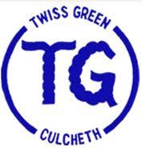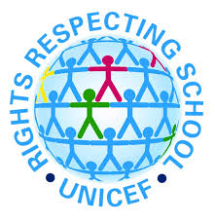
Rights Respecting School Mascot Competition
(Article 42: All adults and children should
know about the UNCRC)
Twiss Green is working hard to become a ‘Rights Respecting School’ and we need your help to remind the children about their rights in the UNCRC and the respectful actions that we must agree to so that everyone can enjoy their rights. Therefore, the school needs a ‘Rights Respecting School’ mascot!
We would like as many children as possible to design their own mascot and the UNICEF team will choose the one that fits best with our school. The mascot will appear on our school charters, on our website and around our school. On the other side of this sheet there are some example of mascots from other schools to give you some ideas. Entries can be returned to school when we open or submitted onto the RRSA blog on Purple Mash (log in and click on the ‘Sharing’ tab).

Name ________________________________________
Year group ____________________________________

