Reception Curriculum Map 2023-2024
 | Autumn 1 | Autumn 2 | Spring 1 | Spring 2 | Summer 1 | Summer 2
Focus Text: | 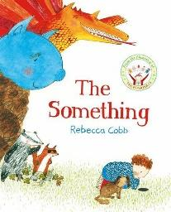  The Something | 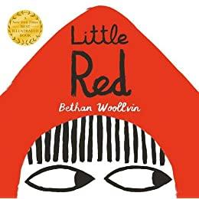  Little Red | 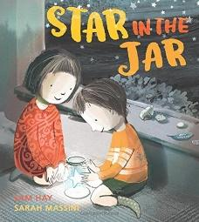  Star in the Jar | 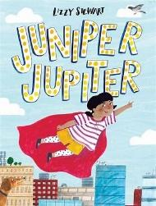  Juniper Jupiter | 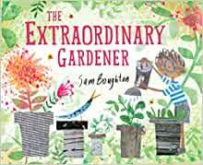  The Extraordinary Gardener | 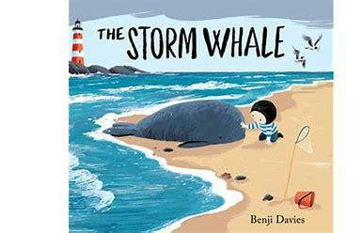  The Storm Whale
English:  Writing Outcome & Purposes | Narrative– A Losing Story  Recount – Animal Information | Narrative – A Finding Story  Information– Poster to find a lost star | Narrative – A Superhero Story  Information – A letter wanting to be a sidekick. | Narrative – A Traditional Tale  Instructions – How to trap an animal | Narrative – A transformational story  Instructions- How to grow a garden plant/ vegetable | Narrative – A Friendship Story  Poems- Sea Creature poems
Communication  and Language - | Listen to others in one-to-one or small groups, when conversation interests them. - child-initiated play  Listens to familiar stories with increasing attention and recall. Story time and continuous provision areas  Joins in with repeated refrains and anticipates key events and phrases in rhymes and stories. - Nursery rhymes | Is able to follow directions (if not intently focused). Daily routines  Shows understanding of prepositions such as under, on top, behind by carrying out an action or selecting correct picture - Link to mathematical vocabulary & Rosie’s Walk  Extends vocabulary, especially by grouping and naming, exploring the meaning and sounds of new words. Story time, new vocabulary from stories planned and revisited throughout the year  Uses language to imagine and recreate roles and experiences in play situations. - Child-initiated play, role play and small world area | Uses talk in pretending that objects stand for something else in their play e.g. This box is my castle. - Explanations of what they have planned/created in the junk modelling area.  Understands questions such as who; why; when; where and how - Focus on questions through planned theme Imagine and Invent  Links statements and sticks to a main theme or intention | Listens and responds to ideas expressed by others in conversations or discussions. - carpet time, circle time, child-initiated play  Develop their own narratives and explanations by connecting ideas and events.  Uses talk to connect ideas, explain what is happening and anticipate what might happen next, recall and relive past experiences.  Introduces a narrative or storyline into their play. Child-initiated play, role play and small world areas | Listen attentively and respond to what they hear with relevant questions, comments, and actions when being read to and during whole class discussions and small group interactions .  Make comments about what they have heard and ask questions to clarify their understanding - child-initiated play, carpet time, adult led activities  Hold conversation when engaged in back-and-forth exchanges with their teachers and peers - child-initiated play, carpet time, adult led activities | Able to follow a story without pictures or props. - Story time - possibly introduce a chapter book.  Express their ideas and feelings about their experiences using full sentences, including the use of past, present and future tenses and making use of conjunctions, with modelling and support from teachers - Children talk about a journey that they have been on. Photographs used as a prompt.
Mathematics | BASELINE  Repeating patterns  Introducing numbers 1-5  Composition of numbers 1-5  Subitising small amounts | Introducing numbers 6-10  Composition of numbers up to 10  Practical exploration of number bonds to 10 | 2D Shapes  Number bonds to 10 exploration  Odd and even  1 more and 1 less  Double and half | Comparing numbers to 10  Bonds to 10  3-D shape  Pattern (2)  ASSESSMENT  SPRING CONSOLIDATION | Building numbers beyond 10  Counting patterns beyond 10  Spatial reasoning (1)  Match, rotate, manipulate  Adding more  Taking away  Spatial reasoning (2)  Compose and decompose | Doubling  Sharing and Grouping  Even and Odd  Spatial reasoning (3)  Visualise and Build  Deepening understanding  Patterns and Relationships  Spatial reasoning (4)  Mapping
Understanding the World | Remembers and talks about significant events in their own experience - Family photo  Talk about members of their immediate family and community - draw pictures of themselves and family members  Name and describe people who are familiar to them - invite familiar people in to talk to the children e.g. nurses/doctors/police etc  Understand that some places are special to members of their community - visit the Methodist Church/walk around local area  Recognise that people have different beliefs and celebrate special times in different ways - link to RE  Understand the effect of changing seasons on the natural world around them - autumn. | Recognise some similarities and differences between life in this country and life in other countries. - Polar regions/Arctic - how do animals keep warm? Blubber experiment  Understand some important processes and changes in the natural world around them - Shadows - Smoot the Rebellious shadow/Melting and freezing - how can we melt the ice to free the characters? (Link to focus stories)  Understand the effect of changing seasons on the natural world around them - winter | Materials - Explore different materials and their properties in Investigation Area  Knows some similarities and differences between things in the past and now, drawing on their experiences and what has been read in class – How have I changed? History of my life.  Understand the past through settings, characters, and events encountered in books read in class and storytelling.  Understand the effect of changing seasons on the natural world around them – winter  Explore the natural world around them, making observations and drawing pictures of animals and plants. | Explore the natural world around them, making observations and drawing pictures of animals and plants -Minibeast hunt, Minibeast habitats, observational drawings and small world exploration  Know some similarities and differences between the natural world around them and contrasting environments, - Bug hotel; what do we need to include for each minibeast? | Make observations of animals and plants and explain why some things occur, and talks about changes - Grow fruits and vegetables in our outdoor area. What do they need to grow?  Know some similarities and differences between the natural world around them and contrasting environments, drawing on their experiences and what has been read in class. - Different climates for fruit and vegetable growth - Where do fruits and vegetables grow? Look at maps and the globe and watch videos of how we get some of the fruits and vegetables that we eat.  Understand the past through settings, characters, and events encountered in books read in class and storytelling. The Tiger Who Came For Tea  Understand the effect of changing seasons on the natural world around them - spring | Recognise some similarities and differences between life in this country and life in other countries. Explore the setting of the story We’re Going on Lion Hunt - How is it different to We’re going on a Bear Hunt? Explore climate, habitats, house and homes etc  Find Africa on a map or globe.  African animals and habitats - small world and non-fiction texts  Knows some similarities and differences between things in the past and now, drawing on their experiences and what has been read in class - Mr Gumpy stories  Understand the past through settings, characters, and events encountered in books read in class and storytelling.  Understand the effect of changing seasons on the natural world around them - summer
PSED  Jigsaw | Develops particular friendships with other children, which help them to understand different points of view and to challenge their own and others’ thinking  Being Me in My World | Returns to the secure base of a familiar adult to recharge and gain emotional support and practical help in difficult situations  Is more aware of their relationships to particular social groups and sensitive to prejudice and discrimination.  Is more able to manage their feelings and tolerate situations in which their wishes cannot be met.  Celebrating Difference | Is proactive in seeking adult support and able to articulate their wants and needs  Has a clear idea about what they want to do in their play and how they want to go about it.  Shows confidence in choosing resources and perseverance in carrying out a chosen task  Is aware of behavioural expectations and sensitive to ideas of justice and fairness  Dreams and Goals | Work and play cooperatively and take turns with others  Shows confidence in speaking to others about eir own needs, wants, interest and opinions in familiar group  Attempts to repair a relationship or situation where they have caused upset and understands how their actions impact other people.  Healthy Me | Is increasingly socially skilled and will take steps to resolve conflicts with other children by negotiating and finding a compromise; sometimes by themselves and sometimes with support  Relationships | Shows sensitivity to their own and to others needs.  Is able to regulate their behaviour according to their own and others’ feelings.  Shows independence, resilience and perseverance in the face of challenge  Changing Me
R.E.  Key Question: | Christianity, Hinduism and Islam  Special times: How and why do we celebrate?  Recognise and describe special times or events for family and friends. UTW link |  | Christianity and Islam  Special stories: Why are some stories special? What special messages can we learn from stories? |  | Christianity, Hinduism and Islam  Special places: What buildings and places are special to different people? OR What is special about our world?
Expressive Arts and Design | Structures: Junk modelling  (D&T Kapow) | Drawing: Marvellous marks (Art & Design Kapow) | Textiles: Bookmarks (D&T Kapow) | Painting and mixed media: Paint my world (Art & Design Kapow) | Structures: Boats (D&T Kapow) | Sculpture and 3D: Creation station (Art & Design Kapow)
P.E. | Introduction to PE:  Unit 1  Fundamentals: Unit 1 | Introduction to PE: Unit 2  Fundamentals: Unit 2 | Gymnastics: Unit 1  Ball Skills: Unit 1 | Games: Unit 1  Dance: Unit 1 | Gymnastics: Unit 2  Ball Skills: Unit 2 | Games: Unit 2  Dance: Unit 2
Music | Me! | My Stories | Everyone | Our World | Big Bear Funk | Reflect, Rewind and Replay

