Year Six Curriculum Map 2024-25
 | Autumn 1 |  | Autumn 2 | Spring 1 |  | Spring 2 | Summer 1 | Summer 2
Vehicle Text: | 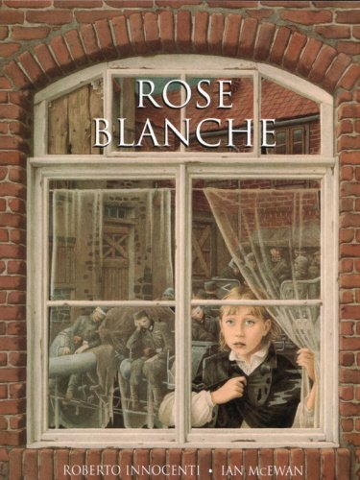  Rose Blanche |  | 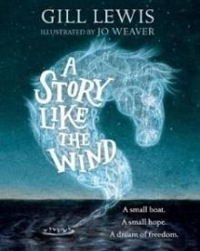  A Story Like the Wind | The Origin of the Species  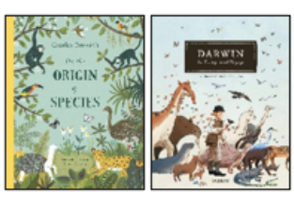 |  | Wolves  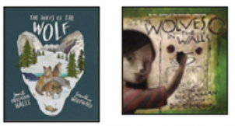 | 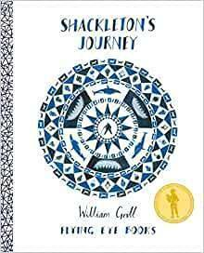  Shackleton’s Journey | 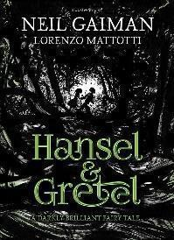  Hansel and Gretel
English:  Writing Outcome  & Purposes | Recount– Diary  Recount – Bravery Speech Award |  | Narrative – Flashback Narrative  Recount – Newspaper Report | Narrative – Discovery Narrative  Explanation– Adaptation |  | Recount – First Person Narrative  Discussion – Balanced Argument  Information text – Wolves  Narrative – Suspense Narrative | Narrative – Endurance Narrative  Recount – Magazine Article | Narrative – Dual Narrative  Persuasion - Letter
Whole Class Reading | 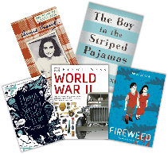  History: War |  | 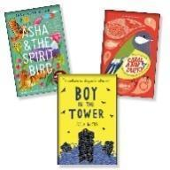  Additional 2-week Science unit: Electricity  Reading Breadth: Modern Fiction & Poetry | 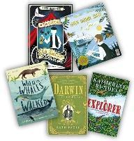  Science: Evolution and Inheritance |  | 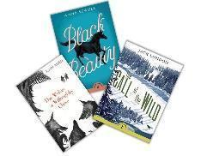  Reading Breadth: Literary Heritage & Plays & Poetry | 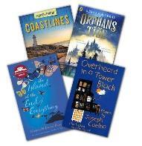  Geography: Coasts | 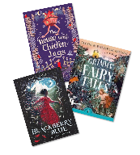  Reading Breadth: Traditional Tales and Poetry
Mathematics | Number: Place Value  Number: Addition, Subtraction, Multiplication and Division |  | Number: Fractions  Units A & B  Measurement: Converting Units | Number: Ratio  Number: Algebra  Number: Decimals |  | Number: Fractions, Decimals and Percentages  Measurement: Area, Perimeter and Volume  Statistics | Geometry: Shape  Geometry: Position and Direction | Themed projects, consolidation and problem solving
Science | Light |  | Electricity | Evolution and Inheritance |  | Living Things and their Habitats  . | Animals including Humans. | Animals including Humans
PSHE - Jigsaw | Being Me in My World |  | Celebrating Difference | Dreams and Goals |  | Healthy Me | Relationships | Changing Me
R.E.  Key Question:  Is life like a journey? | Christianity (God) - How do Christians mark the turning point of life? |  | Hindu Dharma Is there one journey or many? | Islam What is Hajj and why is it important to Muslims? |  | Christianity (Jesus) - Why do Christians believe that ‘Good Friday’ is good? | Buddhism What do we mean by a good life? | Christianity (God) – If life is like a journey, what is the destination?
History | What impact has war and conflict had on our local area (Warrington)? |  |  |  |  |  | Crime and Punishment from the Anglo-Saxons to present day  A study of an aspect or theme in British history that extends pupils’ chronological knowledge beyond 1066.  Securing and deepening knowledge of British history
Geography | Maps, atlases, globes, digital mapping, 8 points of a compass, 4 & 6 figure grid references and field work to be covered throughout the year.
 | Field Study and Mapping Skills Conflict and Memorials in Warrington |  |  | South America  Vegetation Belts, Climate Zones and Biomes  Revisit and deepen: map skills  Revisit and deepen: All living things - classify South American living things/ Charles Darwin
Art & Design | Textiles: Waistcoats |  |  | Drawing: Make My Voice Heard |  |  | Sculpture and 3D: Making Memories
Design & Technology |  | Craft and Design: Photo Opportunity |  |  | Structure: Playgrounds |  |  |  | Digital World: Navigating the World
Spanish | Phonetics 1-4  La Fecha  The Date |  | ¿Tienes una mascota?  Do you have a pet? | La ropa  Clothes |  | En el colegio  At School | El fin de semana  At the Weekend |  | Los vikingos  Vikings
Computing - Purple Mash | Unit 6.2 Internet and E-Safety  Unit 6.4 Blogging |  |  | Unit 5.1 Coding (Revisit)  Unit 6.1 Coding |  |  | Unit 6.6 Networks  Unit 6.8 Understanding Binary
P.E. | Gymnastics  Fitness |  | Dance  Invasion games -  Football | Striking and  Fielding Cricket-  Cheshire Cricket*  Invasion Games-  Basketball |  | Net and Wall Games- Volleyball  Capoeira | OAA  Yoga | Athletics  Striking and Fielding Games- Rounders
Music | Happy  Learning focused around ‘Happy’, a pop song by Pharrell Williams |  | Classroom Jazz 2  Learning focused around two tunes and improvising - Bacharach and Meet the Blues | A New Year Carol  Learning focus is a Friday Afternoons song by Benjamin Britten. |  | You’ve Got a Friend  Learning focus is ‘You’ve Got a Friend’ by Carole King | Music and Me  Learning focus is inspirational women working in music. |  | Reflect, Rewind and Replay  Learning is focused on consolidation and revisiting songs and musical activities.

