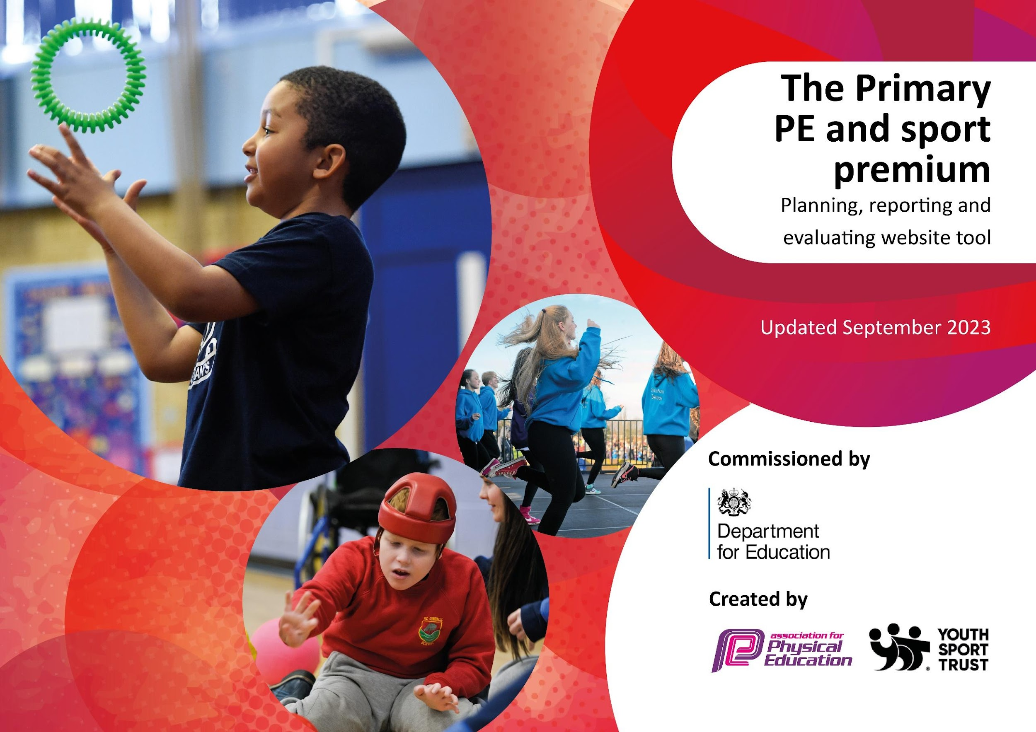

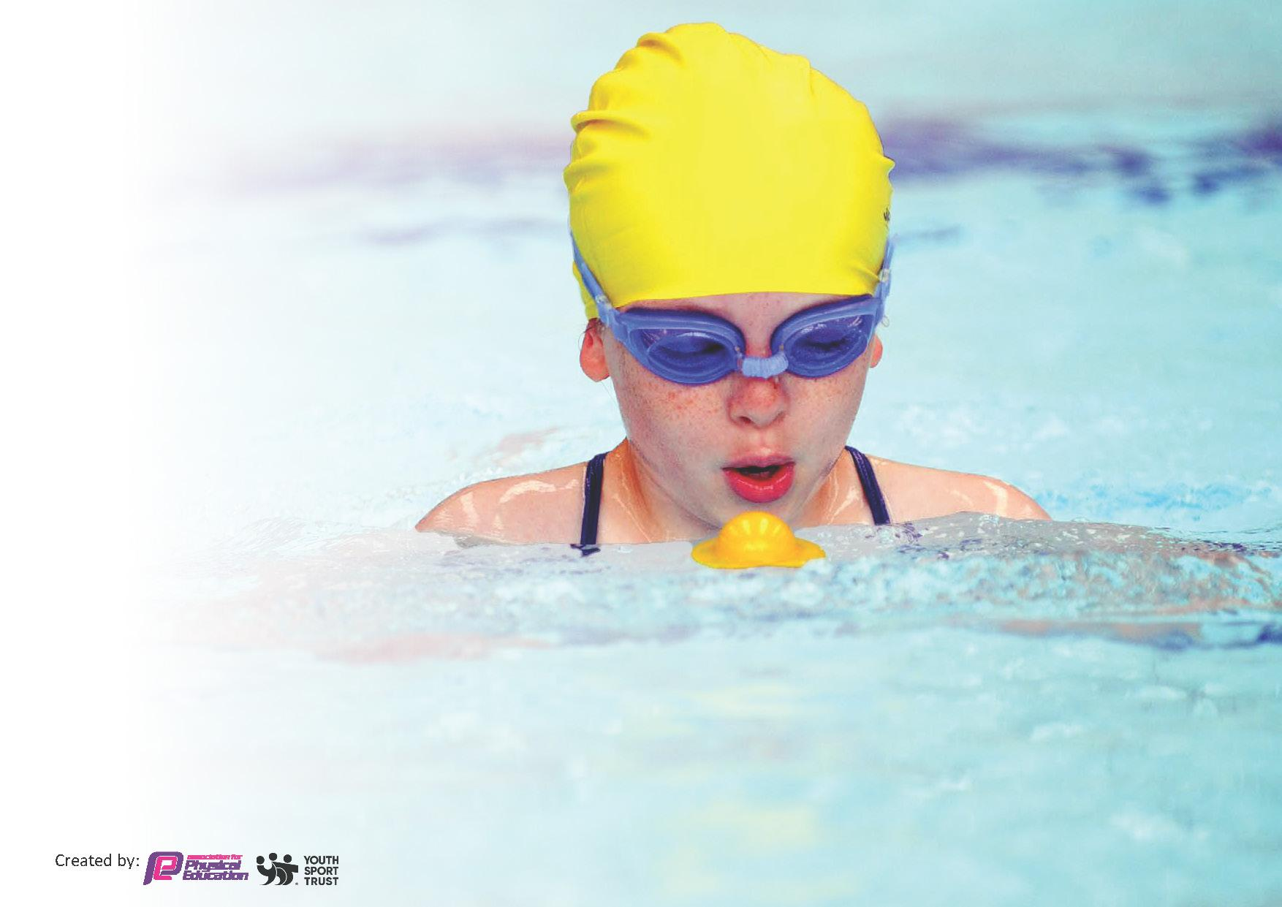
This template can be used for multiple purposes:
by:
- It enables schools to effectively plan their use of the Primary PE and sport premium
- It helps schools to meet the requirements (as set out in guidance) to publish information on their Primary PE and sport premium
- It will be an effective document to support Ofsted inspections enabling schools to evidence progress in Physical Education (PE) and evidence swimming attainment, which forms part of the PE National Curriculum. We would recommend schools consider
the Intent, Implementation and Impact of any spend, as examined within the Education Inspection Framework.

It is important that your grant is used effectively and based on school need.

Schools must use the funding to make additional and sustainable
improvements to the quality of the PE, School Sport and Physical Activity (PESSPA)
they offer. This means that you should use the Primary PE and sport premium to:

- Build capacity and capability within the school to ensure that improvements made now will benefit pupils joining the school in future years
- Develop or add to the PESSPA activities that your school already offers.

The Primary PE and sport premium should not be used to fund capital spend projects; the school’s core budget should fund these. Further detail on capital expenditure can be found in the updated Primary PE and sport premium guidance.

The Primary PE and sport premium guidance, outlines 5 key priorities that funding should be used towards. It is not
necessary that spending has to meet all the key priorities, you should select the priorities that you aim to use any funding towards.

Although completing this template is not a requirement for schools, schools are required to publish details of how they spend this funding. Schools must also outline what the impact this funding has had on pupils’ PE and sport participation and attainment and how any spending will be sustainable in the future. All funding must be spent by 31st July 2024.

The Department for Education has worked closely with the Association for Physical Education (afPE) and the Youth Sport Trust (YST) to develop this template and encourages schools to use it. This template is an effective way of meeting the reporting requirements of the Primary PE and sport premium.
Review of last year’s spend and key achievements (2022/2023)

We recommend you start by reflecting on the impact of current provision and reviewing your previous spend.

Activity/Action | Impact | Comments
-Increased extra-curricular activities  -Transport to competitions and events | -Children have received a wide variety of activities after school  -Children are able to access competitions that they may not have been able to otherwise. | The children accessed a wide variety of activities, benefitting from the inclusive nature of offerings.  We were able to offer more access to competitions, however would like to have more of an offering this academic year.

Key priorities and Planning
This planning template will allow schools to accurately plan their spending.

Action – what are you planning to do | Who does this action impact? | Key indicator to meet | Impacts and how sustainability will be achieved? | Cost linked to the action
Continue to implement OPAL into school during break times and lunchtimes | Lunchtime supervisors / teaching staff, coaches - as they need to lead the activity  All pupils – as they will take part. | Key indicator 2 -The engagement of all pupils in regular physical activity – the Chief Medical Officer guidelines recommend that all children and young people aged 5 to 18 engage in at least 60 minutes of physical activity per day, of which 30 minutes should be in school.  Key indicator 4: Broader experience of a range of sports and activities offered to all pupils. | More pupils meeting their daily physical activity goal, more pupils encouraged to take part in PE and Sport Activities.  Children are to actively engage in play and participate through the OPAL programme | Training for all staff for OPAL  £5300  Resources for activities taking place at lunch  £129.99  £1039.96  £51.96

Service Level Agreement provided by the Local Authority. LiveWire, provides:  - Teaching and learning support  - Pupil achievement and progress  - Staff training and support  - Assessment and planning  - Health and wellbeing  - Safe practice in PE and sport | All teachers and pupils | Key Indicator 1: Increased confidence, knowledge, and skills of all staff in teaching PE and sport.  Key Indicator 3: The profile of PE and sport is raised across the school as a tool for whole school improvement  Key Indicator 4: Broader experience of a range of sports and activities offered to all pupils  Key indicator 5: Increased participation in competitive sport. | Engagement with all CPD aspects of the SLA including  -Subject leader training day  -PE conference  -Support surgeries  -Bespoke support  -Network meetings  -Subject Leader, as well as class teachers, will have support  -Pupils will have access to experience days and competitions  -Expert coaching for rugby | 23/24  £2978
The children will develop fundamental skills, as well as skills linked to specific sports, through the delivery of a progressive curriculum.  Staff will be confident and upskilled throughout the built in staff training provided and the well planned lessons which they will be delivering. | Teaching staff will develop confidence with teaching PE sessions. | Key Indicator 1: Increased confidence, knowledge, and skills of all staff in teaching PE and sport.  Key Indicator 2: Engagement for all pupils in regular physical activity  Key Indicator 3: The profile of PE and sport is raised across the school as a tool for whole school improvement  Key Indicator 4: Broader experience of a range of sports and activities offered to all pupils | -Children have access to a broad curriculum where they are offered a range of activities | Get set 4 PE  £495
During curriculum time, children are given a broad range of activities to participate in.  PE lead will then seek out a wide range of providers to offer a broad range of activities to the children. | Pupils are offered a broad range of activities from specialists | Key Indicator 2: Engagement for all pupils in regular physical activity  Key Indicator 4: Broader experience of a range of sports and activities offered to all pupils | Children have access to a broad curriculum where there are a range of sports and activities that are offered to all pupils | Cheshire Cricket board  £1050  Quidditch  £566  Mini Makery  £510
Provide a wide range of afterschool clubs - particularly targeting the least active. | Pupils have access to a broad range of subjects and activities | Key Indicator 2: Engagement for all pupils in regular physical activity  Key Indicator 3: The profile of PE and sport is raised across the school as a tool for whole school improvement  Key Indicator 4: Broader experience of a range of sports and activities offered to all pupils | Children have a broad experience of a range of activities and can take part in activities linked to their interest | Purple Gecko  £105  £21  £102  £102  Dave Earnden Coaching  £630  £112  £100  £260  Great New Beginnings Yoga  £200  £540  £280  Active Sports  £1221  £180  £120  £180  £120  £648  £360  £240  Sarah Gough Netball  £100  Cricket  £600  Hula fun  £75.17  £348  Gary Brookes- Tennis  £140
To allow all children to participate in competitive sports- including the least active. | Pupils have access to a range of sports and activities that are competitive. | Key Indicator 2: Engagement for all pupils in regular physical activity  Key Indicator 3: The profile of PE and sport is raised across the school as a tool for whole school improvement  Key Indicator 4: Broader experience of a range of sports and activities offered to all pupils  Key Indicator 5: Increased participation in competitive sport | Children have access to a range of competitive activities. | Transport to competitive activities  Gymnastics  £200  £150  £150  Paris Olympics  £790  Lymm High School  £495

Key achievements 2023-2024
This template will be completed at the end of the academic year and will showcase the key achievements schools have made with their Primary PE and sport premium spending.

Activity/Action | Impact | Comments
-Increased participation in competitive sport  -Opal continued to be implemented  -Staff training/ CPD  -A broad range of activities have been offered to the children, both during curriculum time and as extra-curricular activities. | -All children from Years 1-6 have the opportunity to attend a competitive sporting activities  -All children have been able to access OPAL at lunchtimes where a variety of activities has encouraged active engagement.  -Members of staff have attended training including PE subject lead training and OPAL training  -Children have chance to participate in activities that they would not usually be able to participate in. | -We have targeted the least active by including a range of activities by including a variety of active sessions such as hula fun.

Swimming Data
Meeting National Curriculum requirements for swimming and water safety.
Priority should always be given to ensuring that pupils can perform safe self-rescue even if they do not fully meet the first two requirements of the National Curriculum programme of study

Awaiting data from livewire for top up swimming

Question | Stats: | Further context  Relative to local challenges
What percentage of your current Year 6 cohort can swim competently, confidently and proficiently over a distance of at least 25 metres? | 86.7% | Awaiting top up swimming data from livewire
What percentage of your current Year 6 cohort can use a range of strokes effectively [for example, front crawl, backstroke, and breaststroke]? | 83.3% | Awaiting top up swimming data from livewire

What percentage of your current Year 6 cohort are able to perform safe self-rescue in different water-based situations? | 86.7% | Awaiting top up swimming data from livewire
If your schools swimming data is below national expectation, you can choose to use the Primary PE and sport premium to provide additional top-up sessions for those pupils that did not meet National Curriculum  requirements after the completion of core lessons. Have you done this? | Yes/No
Have you provided CPD to improve the knowledge and confidence of staff to be able to teach swimming and water safety? | Yes/No

Signed off by:

Head Teacher: | Natalie Hughes
Subject Leader or the individual responsible for the Primary PE and sport premium: | Sian Lea- PE Subject Lead
Governor: | Liz Davis (Chair of Governors)
Date: | 22/07/24

