Year Two Curriculum Map 2022-2023

 | Autumn 1 |  | Autumn 2 | Spring 1 |  | Spring 2 | Summer 1 | Summer 2
Focus Text: | 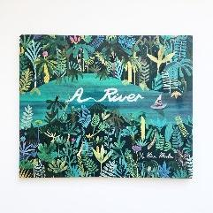  River |  | The Night Gardener  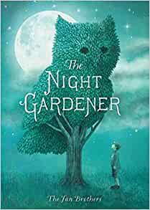 | 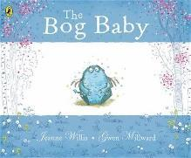  The Bog Baby |  | 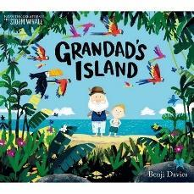  Grandad’s Island | 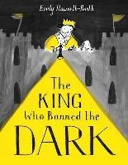  The King Who Banned the Dark | Rosie Revere  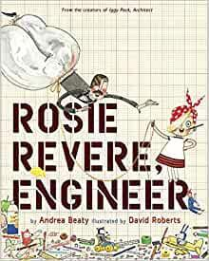
English:  Writing Outcome & Purposes | Narrative– Circular Narrative  Recount – Letter |  | Narrative – Setting Narrative  Recount – Diary | Narrative – Finding Narrative  Instructions – How to build a habitat |  | Narrative – Return Narrative  Information – Jungle Animals | Narrative – A Mistake Narrative  Information– How to be a Regal Leader | Narrative – Invention Narrative  Explanation – How a machine works
Whole Class Reading | 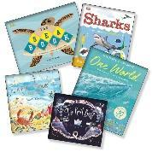  Geography: Rivers and Seas |  | 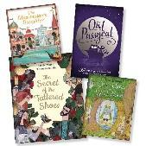  Reading Breadth: Fairy Stories and Poetry - Classics | 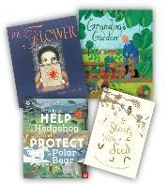  Science: Living Things/ Habitats/ Plants |  | 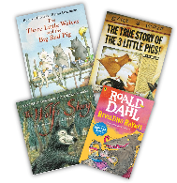  Reading Breadth: Traditional Tales and Poems - Contemporary | 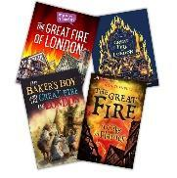  History: Events Beyond Living Memory – The Great Fire of London | 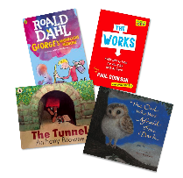  Reading Breadth: Stories and Plays & Poetry- Contemporary
Mathematics | Place Value  Addition and Subtraction  Shape |  |  | Addition and Subtraction  Money  Multiplication and Division  Mass, capacity and temperature |  |  | Fractions  Time  Length and Height  Statistics  Position and Direction
Science | Uses of Everyday Materials |  |  | Living Things and their Habitats |  |  | Plants | Animals including humans
PSHE - Jigsaw | Being Me in My World |  | Celebrating Difference | Dreams and Goals |  | Healthy Me | Relationships | Changing Me
R.E.  Key Question: How do we respond to the things that really matter? | Christianity (God)  Does how we treat the world matter?  Creation,  Care for the planet, Harvest. |  | Christianity (Jesus)  Why do Christians say Jesus is the ‘Light of the World’?  Jesus is the light of the world,  symbolism of light,  Advent, and  Christmas. | Hindu Dharma  How might people express their devotion?  Devotion,  worship in the home and temple |  | Islam  Why do Muslims  believe it is important to obey God?  Submission and  gratitude,  prayer | Christianity (Church)  What unites the  Christian community? Worship,  the church,  and the use of symbols. | Judaism  What aspects of life really matter?  Moses,  Ten Commandments, the Sabbath.
History |  |  | Why do we  remember?  The lives of  significant individuals  in the past who have  contributed to  national and  international  achievements. | Would a fire in our capital city today cause as much damage as the Great Fire of London?  Events beyond  living memory that are  significant nationally  or globally |  |  | Who was George Stephenson and why is he so significant to the area we live in?  Significant historical events, people and  places in their own locality
Geography | Maps, atlases, globes, digital mapping, 4 points of a compass and field work to be covered throughout the year.
 | Hot and cold  places  Location of hot  and cold areas of the  world in relation to  the Equator and the  North and South  Poles. |  |  |  |  | Contrasting  Locality  studying the human  and physical  geography of a small  area of the United  Kingdom, and of a  small area in a  contrasting non-  European country | Mapping Our Local Area linked to  Railway topic and its impact on the local area
Art & Design |  | Formal Elements of Art |  |  | Art and Design Skills |  |  |  | Art and Design Making faces
Design & Technology | Structures: Baby bear's chair |  |  | Mechanisms: Fairground Wheel |  |  | Mechanisms- Making a moving monster |  | Hidden sugars in drinks
Computing - Purple Mash | Online Safety- Unit 2.2  Effective Searching- Unit 2.5 |  |  | Coding Unit 1.7 (Revisit)  Coding Unit 2.7 |  |  | Spreadsheets- Unit 2.3  Creating Pictures- Unit 2.6
P.E. | Fundamentals  Team Building |  | Gymnastics  Ball Skills | Cricket - Cheshire Cricket  Dance |  | Sending and Receiving  Target Game | Fitness  Invasion | Athletics  Net and Wal
Music | Hands, Feet, Heart |  | Ho, Ho, Ho | I Wanna Play In A Band |  | Zootime | Friendship Song | Reflect, Rewind and Replay
Spanish | Register in Spanish  Numbers to 10  Spanish greetings song |  | Register in Spanish  Numbers to 10  Spanish greetings song | Register in Spanish  Numbers to 10  Spanish greetings song |  | Register in Spanish  Numbers to 10  Spanish greetings song | Register in Spanish  Numbers to 10  Spanish greetings song | Register in Spanish  Numbers to 10  Spanish greetings song

