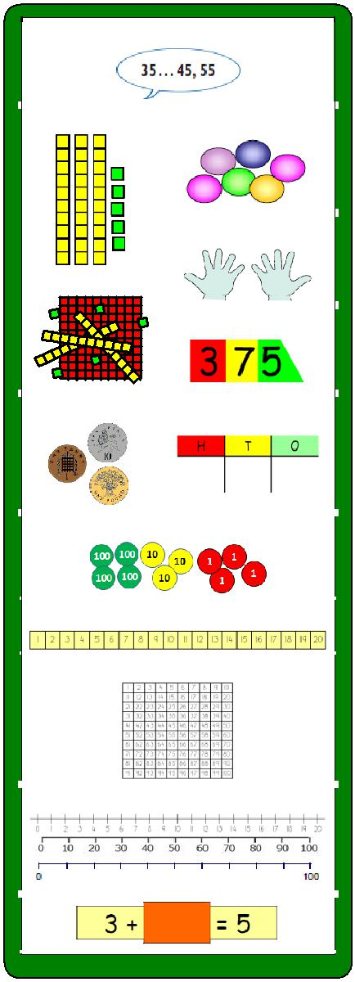
Twiss Green
Progression in
Mental Calculation

Ask yourself:

Can I do it in my head using a mental strategy?
Could I use some jottings?
Should I use a written method?

MENTAL ADDITION

Year 1
add and subtract one-digit and two-digit numbers to

20 including zero

represent and use number bonds and related subtraction facts within 20

Pupils memorise and reason with number bonds to 10 and 20 in several forms (e.g. 9 + 7 = 16; 16 – 7 =

9; 7 = 16 - 9).
Add two one-digit numbers

e.g. 3 + 5, 6 + = 9

Add two one-digit numbers

e.g. 8 + 6, 5 + = 12

Add a 'teens' number and ones

e.g. 13 + 5, + 3 = 17

Also include:
Adding zero

e.g. 3 + 0, 15 + 0, 0 + = 5

Mental strategies:
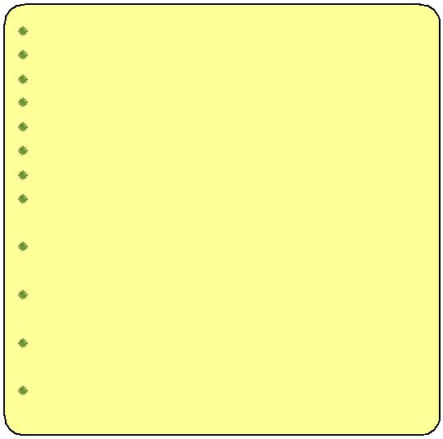
count on in ones;

1 more than a number;

10 more than a multiple of 10;

add by counting on from the larger number; reorder numbers in a calculation;

look for pairs that make 10;

look for doubles and near doubles;

begin to bridge through 10 when adding a one-digit number;

use known facts and place value to add pairs of one-digit numbers;

partition and recombine by breaking units of 6, 7, 8 or 9 into ‘5 and a bit’;

Add 9 to single-digit numbers by adding 10 then subtracting 1;
use patterns of similar calculations;

Year 2
add and subtract numbers using concrete objects, pictorial representations, and mentally, including:

- a two-digit number and ones, a two-digit number and tens , two two-digit numbers
- adding three one-digit numbers
Add three one-digit numbers

e.g. 6 + 8 + 4, 6 + 3 + 6, 8 + 9 + 7

Add a two-digit number and ones

e.g. 43 + 5, 31 + = 38, 27 + 6, 46 + = 52

Add a two-digit number and tens

e.g. 23 + 40, 47 + = 77, + 30 = 81
Add pairs of two-digit numbers

e.g. 41 + 32, 31 + = 54, 35 + 47, 27 + = 82

Also include:
Added to any two-digit number to make the next ten

e.g. 64 + = 70

Add a tens number to any tens number

e.g. 50 + 30, 40 + 60, 70 + 80, 30 + 80 + 50

Mental strategies:
count on in tens or ones; reorder numbers in a calculation;

add three 1-digit numbers; put the largest number first, using known facts (pairs to 10, doubles);

add by partitioning into tens and ones then recombine; bridge through a multiple of 10;

use number facts and place value to add pairs of numbers;

add 9, 19, 11 or 21 by rounding and compensating; use patterns of similar calculations;

Year 3
add and subtract numbers mentally, including:

- a three-digit number and ones

- a three-digit number and tens

- a three-digit number and hundreds

Add a three-digit number and ones

e.g. 231 + 6, 241 + = 248, 175 + 8

Add a three-digit number and tens

e.g. 249 + 50, 167 + 60, 431 + = 481

Add a three-digit number and hundreds
e.g. 381 + 400, 751 + 300, 231 + = 531

Also include:
Add pairs of two-digit numbers

e.g. 72 + 41, 87 + = 121, 65 + 57

Added to any three-digit number to make the next ten or hundred

e.g. 247 +  = 250, 647 +  = 700

Add three small numbers

e.g. 13 + 8 + 7, 8 + 13 + 8, 8 + 15 + 17

Mental strategies:
count on in hundreds, tens or ones; add mentally a ‘near multiple of 10’; add 3 or 4 small numbers;

partition into hundreds, tens and ones and in different ways, then recombine (724 = 700 + 20 + 4)

(724 = 600 + 110 + 14);
reorder numbers in a calculation;

bridge through a multiple of 10, then adjust; use known facts and place value to add; use patterns of similar calculations;

use the relationship between addition and subtractio
MENTAL ADDITION
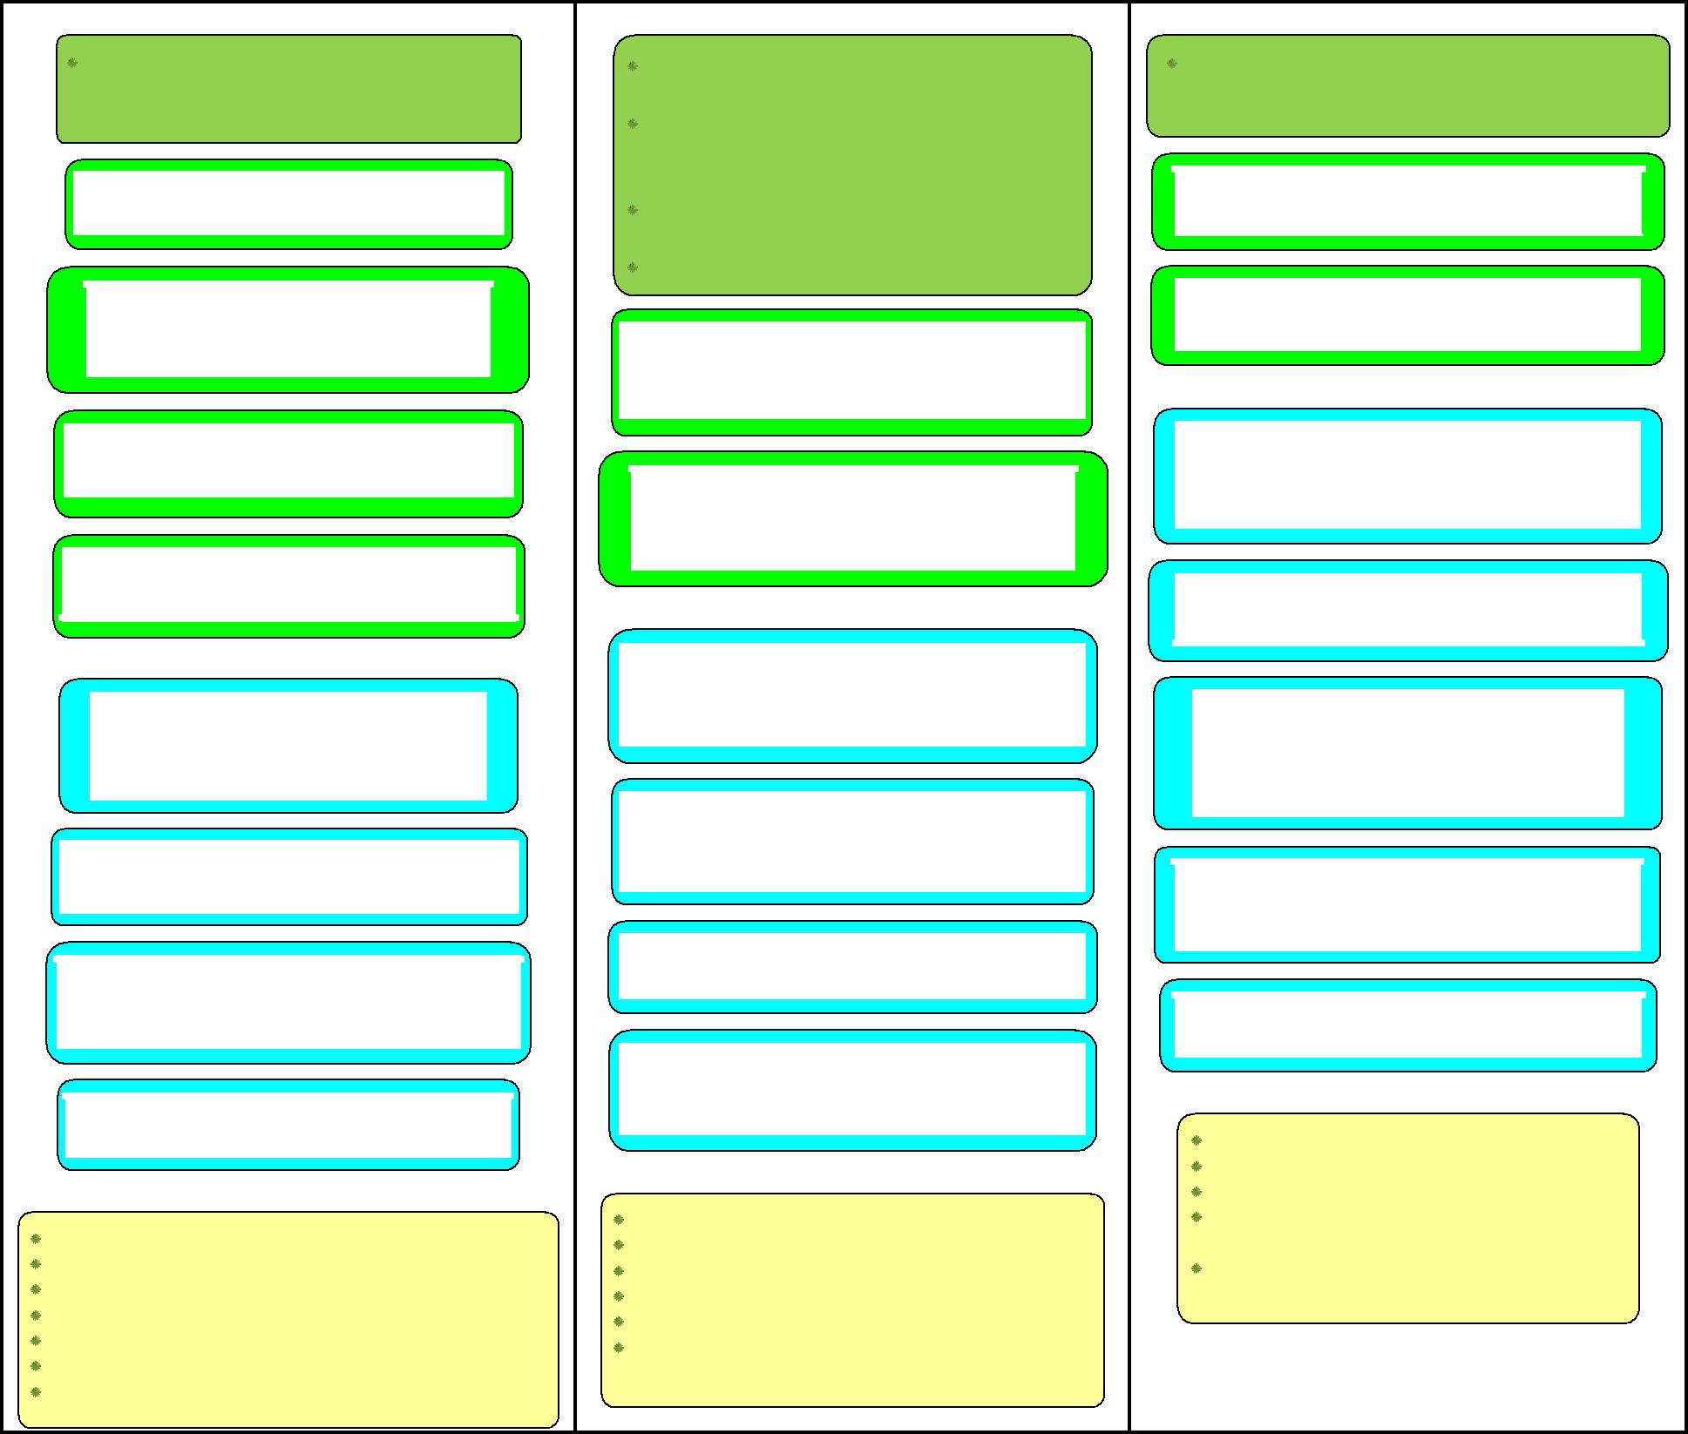

Year 4

Pupils continue to practise both mental … addition and subtraction with increasingly large numbers to aid fluency

Add a four-digit number and ones

e.g. 4312 + 6, 3441 + = 3443, 1029 + 5

Add a four-digit number and tens

e g 1735 + 40 2143 + = 2193 3781 + 70

Add a four-digit number and hundreds

e.g. 2175 + 400, 3248 + = 3948, 4505 + 600

Add a 4-digit number and thousands

e.g. 1367 + 4000, 5648 + = 7648

Also include:

Add a two-digit number to a three-digit tens

e.g. 430 + 54, 610 +  = 637, 560 + 76

Add any pair of three-digit multiple of 10

e.g. 430 + 260, 570 + 250

Added to any three-digit number to make the next multiple of 1000

e.g. 370 +  = 1000, 1452 +  = 2000

Add three two-digit numbers

e.g. 34 + 13 + 43, 33 + 52 + 21

Mental strategies:

count on in steps of 1, 10, 100, or 1000; reorder numbers in a calculation;
add 3 or 4 small numbers;

partition, adding the most significant digit first; use known facts and place value to add;

add the nearest multiple of 10 or 100 then adjust;

use the relationship between addition and subtraction;

Year 5

add and subtract numbers mentally with increasingly large numbers

They practise mental calculations with increasingly large numbers e.g.12462 – 2300 = 10 162).

They mentally add and subtract tenths, and one-digit whole numbers and tenths. …complements of 1 (0.83 + 0.17 = 1)

Add tenths to a one-digit whole number and tenths

e.g. 5.4 + 0.3, 2.6 + 0.8, 4.3 +  = 4.9

Add two one-digit whole numbers and tenths

e.g. 5.4 + 2.5, 2.4 + 8.1, 2.4 +  = 7.6

Also include:

Add four-digit multiple of 100 to a five-digit number

e.g. 32 634 + 2 100, 18 251 + 7 100

Added to a decimal fraction with units and tenths to make the next whole number
e.g. 4.3 +  = 5, 7.3 +  = 8

Add any pair of three-digit multiples of 10

e.g. 390 + 340, 570 + 780, + 350 = 810

Add two numbers with tenths and hundredths

e.g. 0.57 + 0.32, 0.48 + 0.69 , 0.24 +  = 0.71

Mental strategies:

count on in steps of 0.1, 1, 10, 100, or 1000; reorder numbers in a calculation;

partition, adding the most significant digit first; use known facts and place value to add;

add the nearest multiple of 1, 10 or 100 then adjust; develop further the relationship between addition and subtraction;

Year 6

They undertake mental calculations with increasingly large numbers and more complex calculations.

Add large numbers

e.g. 129 000 + 34 000

Add negative numbers in context

e.g. rise from -3ºC by 1ºC, from -6ºC by 9ºC

Also include:

Add several one-digit whole numbers and tenths

e.g. 2.3 + 5.7 + 3.9, 1.2 + 4.6 +  = 7.3

Add decimals with different number of places

e.g. 0.67+ 0.2, 0.5 +  = 0.87

Added to any number with two decimal places to make the next tenth or whole
e.g. 3.65 +  = 4, 7.36 +  = 7.4

Added to any number with three decimal places to make the next tenth or whole

e.g. 6.173 +  = 6, 1.306 +  = 1.4

Add any pair of 4-digit multiples of 100

e.g. 5700 + 2500, 2400 + 8700

Mental strategies:

consolidate all strategies from previous years; partition, adding the most significant digit first; use known facts and place value to add;

add the nearest multiple of 0.1, 10, 100 or 1000, then adjust;

continue to use the relationship between addition and subtractio
MENTAL SUBTRACTION
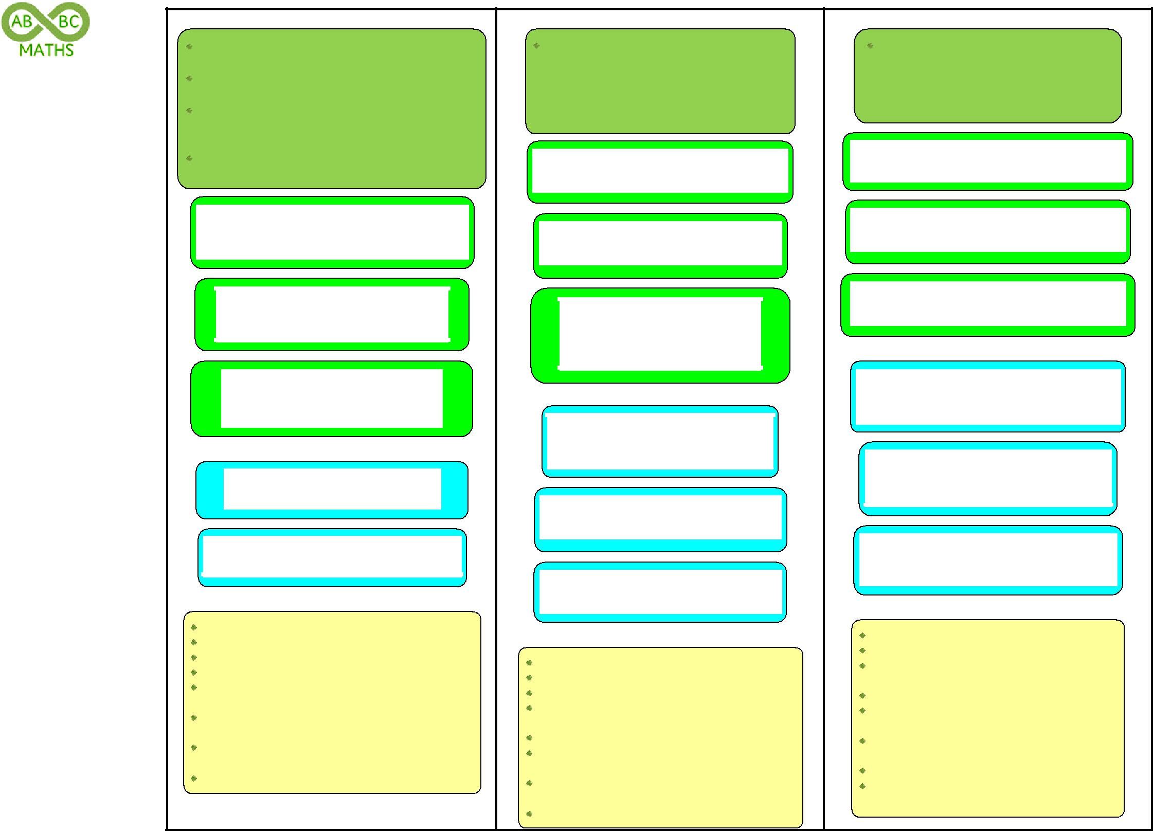

Year 1

add and subtract one-digit and two-digit numbers to 20 including zero

represent and use number bonds and related subtraction facts within 20

Pupils memorise and reason with number bonds to 10 and 20 in several forms (e.g. 9 + 7 = 16;

16 – 7 = 9; 7 = 16 - 9).

They should realise the effect of adding or subtracting zero

Subtract a small number from one-digit numbers

e.g. 9 – 2, 8 - 3, 8 - = 7

Subtract two one-digit numbers

(small difference) e.g. 8 - 6, 9 - = 6

Subtract a ones from a 'teens' number

e.g. 16 - 5, 14 - 6, - 3 = 11, 14 - = 9

Also include:

Subtract zero

e.g. 3 - 0, 15 - 0, 12 - = 7

Subtract ones from 10 or 20

e.g. 10 - 4, 20 - 4, 10 - = 2, 20 - = 11

Mental strategies:

count back in ones;

1 less than a number;

10 less than a multiple of 10;

take away a small number by counting back; find a small difference by counting on (using equipment);

begin to bridge through 10, when subtracting a one-digit number;

use known number facts and place value to subtract one-digit numbers;

use patterns of similar calculations;

Year 2

add and subtract numbers using concrete objects, pictorial representations, and mentally, including:

- a two-digit number and ones, a two-digit number and tens , two two-digit numbers
- adding three one-digit numbers

Subtract ones from a two-digit number

e.g. 48 - 5, 36 - = 31, 23 - 6, 56 - = 59

Subtract tens from a two-digit number

e.g. 73 - 30, 51 - = 21, - 30 = 61,

Subtract pairs of two-digit numbers

e.g. 47 - 22, 85 - = 54, 63 - 47, 72 - = 56

Also include:

Subtract pairs of two-digit numbers

(difference less than 10) e.g. 47 - 42, 63 – 58, 71 - = 68

Subtract ones from a tens number

e.g. 30 – 4, 70 - = 61

Subtract tens from a tens number

e.g. 80 – 40, 70 - = 20, 100 – 20, 120 - 50

Mental strategies:

count back in tens or ones;

subtract mentally a ‘near multiple of 10’; take away a small number by counting back: find a small difference by counting up from the

smaller to the larger number (on a number line); bridge through a multiple of 10, then adjust;

use knowledge of number facts and place value to subtract pairs of numbers;

subtract by partitioning second number and subtracting tens then ones;

use patterns of similar calculations;

Year 3

add and subtract numbers mentally, including:
- a three-digit number and ones

- a three-digit number and tens

- a three-digit number and hundreds

Subtract ones from a three-digit number

e.g. 237 - 6, 258 - = 252, 375 – 8, 301 - 3

Subtract tens from a three-digit number

e.g. 475 - 40, 217 - 60, 581 - = 521, 213 - 40

Subtract hundreds from a three-digit number

e.g. 981 - 400, 951 - 800, 631 - = 231

Also include:

Subtract pairs of three-digit numbers

(difference less than 10)

e.g. 458 – 451, 305 – 297, 603 – 597

Subtract ones from a three-digit tens number

e.g. 280 – 5, 800 – 4, 500 - = 498

Subtract a two-digit number from a one hundred three-digit number

e.g. 127 – 72, 143 - 86

Mental strategies:

count back in hundreds, tens or ones; subtract mentally a ‘near multiple of 10’;

find a small difference by counting up from the smaller to the larger number (on a number line); bridge through a multiple of 10, then adjust; use knowledge of number facts and place value to subtract pairs of numbers;

subtract a 2-digit number by partitioning it subtracting its tens then ones;
use patterns of similar calculations;

use the relationship between addition and subtractio
MENTAL SUBTRACTION
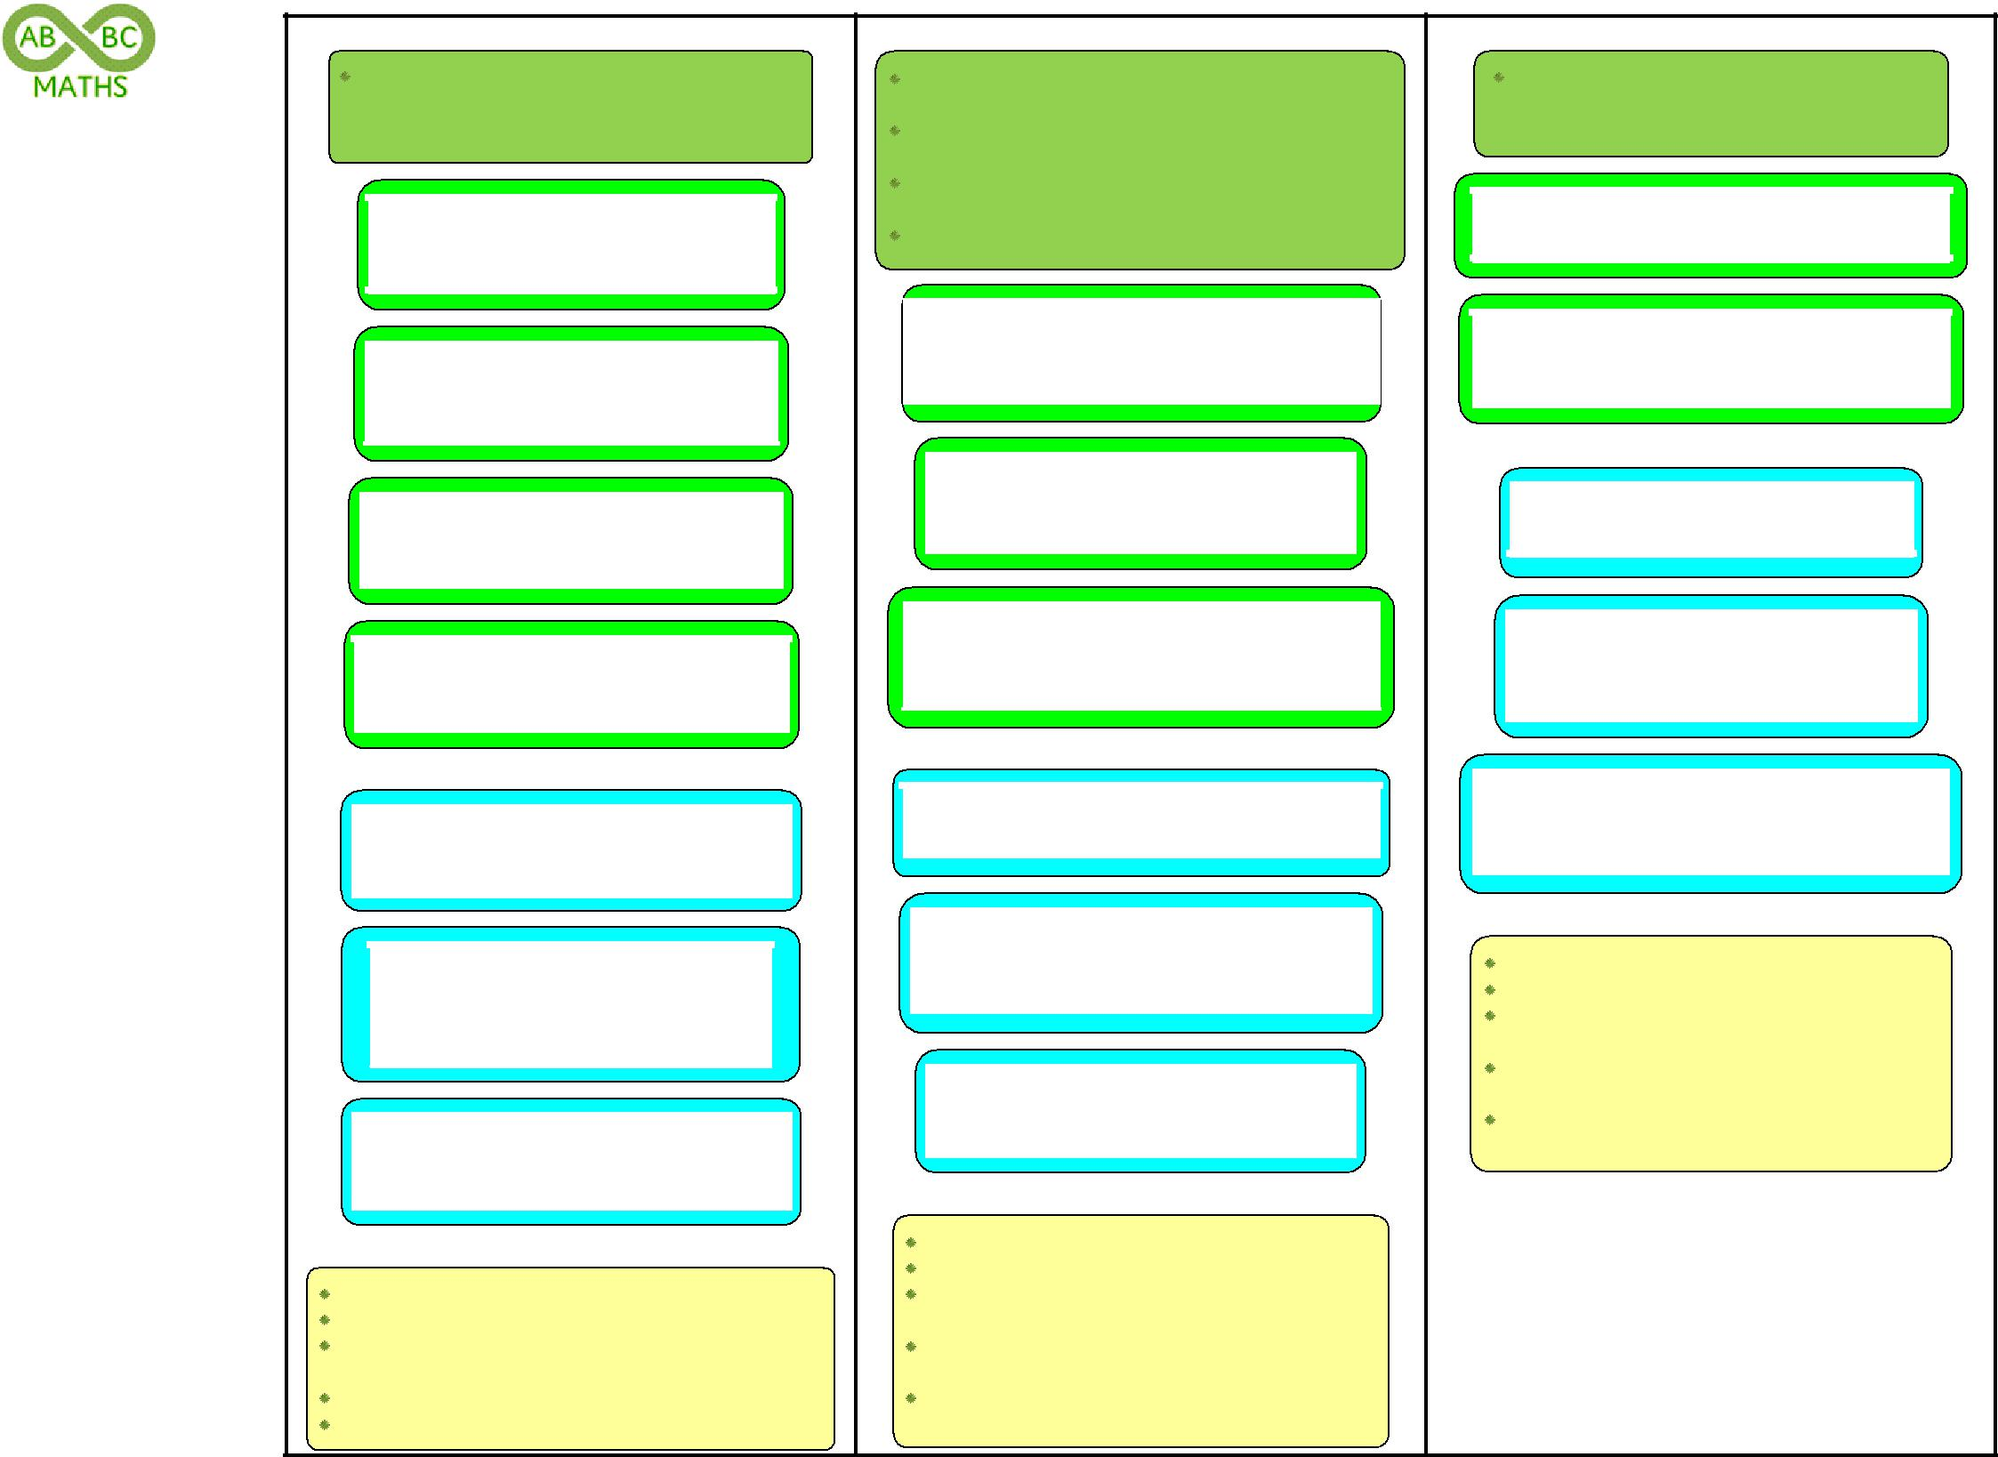

Year 4

Pupils continue to practise both mental … addition and subtraction with increasingly large numbers to aid fluency

Subtract ones from a four-digit number

e.g. 4319 - 6, 3486 - = 3481, 2023 - 5

Subtract tens from a four-digit number

e.g. 1375 - 40, 5163 + = 5113, 3731 - 70

Subtract hundreds from a four-digit number

e.g. 5629 - 400, 4648 - = 4148, 4505 - 600

Subtract a four-digit number and thousands

e.g. 6173 - 4000, 8649 - = 3649

Also include:

Subtract three-digit multiple of 10 from a three-digit number

e.g. 742 – 210, 516 – = 146, – 340 = 685

Subtract three-digit multiple of ten from a thousands number

e.g. 3000 – 230, 7000 – = 6480, 5000 – 540

Subtract a pair of numbers lying either side of a thousands number
e.g. 7003 – 6988, 6004 – = 19

Mental strategies:

count back in steps of 1, 10, 100, or 1000; use known facts and place value to subtract ;

find a difference by counting up through the next multiple of 10, 100 or 1000;

subtract the nearest multiple of 10 or 100 then adjust; use the relationship between addition and subtraction;

Year 5

add and subtract numbers mentally with increasingly large numbers

They practise mental calculations with increasingly large numbers (e.g.12462 – 2300 = 10 162).

They mentally add and subtract tenths, and one-digit whole numbers and tenths.

…complements of 1 (0.83 + 0.17 = 1)

Subtract tenths from a one-digit whole numbers and tenths

e.g. 5.4 - 0.3, 2.6 - 0.8, 4.3 - = 3.9

Subtract two one-digit whole numbers and tenths

e.g. 5.4 - 2.5, 8.2 - 5.7, 2.4 - = 1.6

Subtract four-digit multiple of 100 from a five-digit number

e.g. 25 935 - 2 100, 19 412 + 7 500

Also include:

Subtract two near multiple of thousands

e.g. 5001 – 1997, 8006 – 2993, 4005 – 1997

Subtract two numbers with tenths and hundredths

e.g. 0.57 - 0.32, 0.41 - 0.26 , 0.64 - = 0.37

Subtract a one-digit whole number and tenths from a whole number

e.g. 7 - 5.4, 12 – 7.6, 21 - = 17.6, 20 – 2.7

Mental strategies:

count back in steps of 0.1, 1, 10, 100, or 1000; use known facts and place value to subtract ; find a difference by counting up through the next multiple of 10, 100 or 1000;

subtract the nearest multiple of 1, 10 or 100 then adjust;

develop further the relationship between addition and subtraction;

Year 6

They undertake mental calculations with increasingly large numbers and more complex calculations.

Subtract large numbers

e.g. 269 000 – 42 000

Subtract negative numbers in context

e.g. decrease from 2ºC to -4ºC, reduce -6ºC by -5ºC

Also include:

Subtract four-digit multiples of 100

e.g. 6200 – 3800, 6100 – = 3700

Subtract any number with three decimal places from a whole number
e.g. 5 – 0.314, 12 – 0.176, 1 - = 0.368

Subtract decimals with a different number of decimal places

e.g. 0.67 - 0.2, 0.9 - = 0.53

Mental strategies:

consolidate all strategies from previous years; use known facts and place value to subtract; find a difference by counting up through the next multiple of 10, 100 or 1000;

subtract the nearest multiple of 0.1, 10, 100 or 1000, then adjust;

continue to use the relationship between addition and subtractio
MENTAL MULTIPLICATION

Year 1
solve simple one-step problems involving multiplication and division, by calculating the answer using concrete objects, pictorial representations and arrays with the support of the teacher.

They make connections between arrays, number patterns, and counting in twos, fives and tens.

Give children experience of counting equal group of objects in 2s, 5s and 10s.

Present practical problem solving activities involving counting equal sets or groups

Also include:
Doubles of all numbers to 10

Mental strategies:
counting in twos, fives and tens; repeated addition;

links to doubling; use arrays;

Year 2
recall and use multiplication and division facts for the 2, 5 and 10 multiplication tables, including recognising odd and even numbers

solve problems involving multiplication and division, using materials, arrays, repeated addition, mental methods, and multiplication and division facts, including problems in contexts

They begin to use other multiplication tables and recall multiplication facts … to perform … mental calculations.
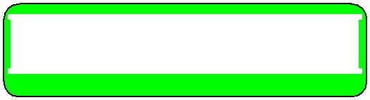

Multiplication facts for x2, x5 and x10

e.g. 2 x 5, 5 x 6, 10 x 5, 5 x = 20

Also include:

Doubles to 20

e.g. double 11, double 16, 13 + 13

Mental strategies:
counting in twos, fives and tens; repeated addition;

use arrays;

use known facts and place value to multiply by 2, 5 or 10;
links to doubling;

reorder a calculation, knowing multiplication can be done in any order (commutative);
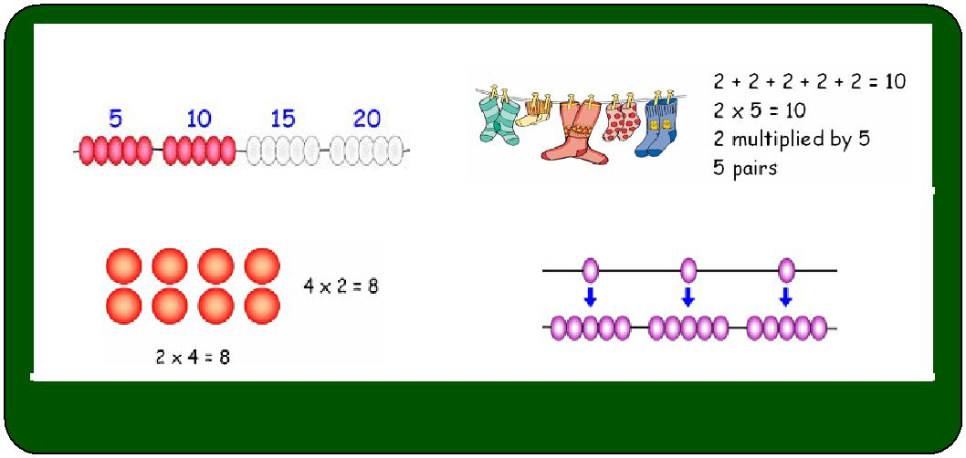
Year 3
recall and use multiplication and division facts for the 3, 4 and 8 multiplication tables

write and calculate mathematical statements for multiplication and division using the multiplication tables that they know, including:

− two-digit numbers by one-digit numbers …using mental methods

Pupils develop efficient mental methods, for example, using commutativity and associativity (e.g. 4 × 12 × 5 = 4 × 5 × 12 = 20 × 12 = 240) and multiplication and division facts (e.g. using 3 × 2 = 6,) to derive related facts (30 × 2 = 60, …).

Multiplication facts for x3, x4 and x8

e.g. 8 x 6, 3 x 6, 4 x 7, 3 x = 24
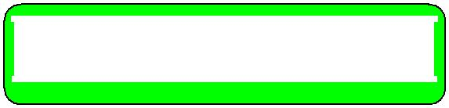

Multiply a 'teens' number by 2, 3, 4, 5 or 8

e.g. 14 x 3, 17 x 4

Multiply a one-digit by a multiple of 10

e.g. 30 x 2, 5 x 40, 8 x = 320

Multiply a two-digit by a one-digit number

e.g. 32 x 3, 4 x 23, 5 x = 155

Also include:
Doubles to 50

Multiply 3 numbers within known tables

Commutative law
2 x 3 = 3 x 2

Associative law

(2 x 3) x 4 = 2 x (3 x 4)

Repeated addition
Counting in equal steps
(2s, 3s, 4s, 5s & 10s)

Describing an array | Scaling (from Yr 3)

e.g. 3 x 2 x 8, 4 x 3 x 5

Mental strategies:
counting in 2s, 5s, 10s, 3s, 4s and 8s; repeated addition;

use known facts and place value to multiply by 2, 3, 4, 5 8 or 10;

use doubles to link x2, x4 and x8 tables; reorder a calculation using commutativity; use the rule of associativity;
scaling up using known facts;

use the relationship between multiplication and division;

MENTAL MULTIPLICATION

Factor pairs

2 x 3 = 6, 6 has a factor pair

of 2 and 3

Distributive law
39 x 7 = 30 x 7 + 9 x 7

Associative law

14 x 12 = (2 x 7) x 12 = 2 x (7 x 12)

Year 4
recall multiplication and division facts for multiplication tables up to 12 x 12

use place value, known and derived facts to multiply and divide mentally, including: multiplying by 0 and 1; dividing by 1; multiplying together three numbers recognise and use factor pairs and commutativity in mental calculations

Pupils practise mental methods and extend this to three-digit numbers to derive facts, (e.g. 600 ÷ 3 = 200 can be derived from 2 x 3 = 6).

Multiply numbers to 12 x 12

e.g. 8 x 12, 9 x 7, 12 x 6, 11 x = 121

Multiplying 3 numbers

e.g. 8 x 7 x 5, 5 x 14 x 4, 15 x 4 x 2
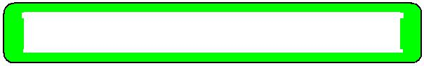

Multiply by 1 and 0

Also include:
Multiply a number to 12 by a multiple of 10

e.g. 12 x 70, 90 x 6, 8 x = 560

Multiply a number to 12 by a multiple of 100

e.g. 300 x 7, 9 x 400, 900 x = 8100

Multiply a 'teens' number by a 1-digit number

e.g. 15 x 8, 16 x 9, 6 x 17

Doubles of any 2-digit numbers

Mental strategies:
counting in 6, 7, 9, 25 and 1000;

use commutativity and tables to multiply;

use partitioning and Distributive Law to multiply; use factor pairs and the Associative Law to multiply; use known facts and place value to multiply;
use related facts to multiply; scaling up using known facts;

Year 5
multiply and divide numbers mentally drawing upon known facts

multiply and divide whole numbers and those involving decimals by 10, 100 and 1000

solve problems involving multiplication and division including using their knowledge of factors and multiples, squares and cubes
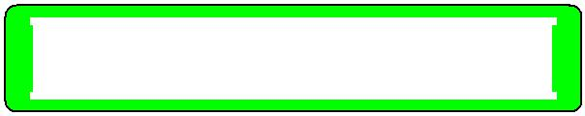
Multiply a two-digit by a one-digit number

e.g. 4 x 35, 23 x 6, 28 x = 140

Multiply whole numbers by 10, 100 and 1000

e.g. 327 x 10, 96 x 100, 83 x 1000

Multiply decimals by 10, 100 and 1000

e.g. 3.27 x 10, 5.4 x 100, 0.82 x = 82

Also include:
Multiply a multiple of 10 by a multiple of 10

e.g. 50 x 60, 90 x 70, 60 x = 42 000

Multiplying 3 numbers (including tens)

e.g. 3 x 40 x 6, 70 x 5 x 20

Double any multiple of 5 up to 500

Mental strategies:
counting in steps of powers of 10;

use commutativity and tables to multiply;

use partitioning and Distributive Law to multiply; use factor pairs and the Associative Law to multiply; use known facts and place value to multiply;

use related facts to multiply; scaling up using known facts;

use the relationship between multiplication and division;

recognise and use square and cube numbers;

Year 6
multiply one-digit numbers with up to two decimal places by whole numbers

multiply and divide numbers by 10, 100 and 1000 where the answers are up to three decimal places

Pupils multiply decimals by whole numbers, starting with the simplest cases, such as 0.4 x 2 = 0.8, and in practical contexts, such as measures and money.

Pupils continue to use all the multiplication tables to calculate mathematical statements in order to maintain their fluency.
Multiply a tenth number by a one-digit number

e.g. 0.4 x 9, 6 x = 4.8, x 7 = 4.9

Multiply a hundredths number by a one-digit number

e.g. 0.06 x 3, 9 x 0.03, 8 x = 0.56

Also include:
Multiply a multiple of 10 by a multiple of 100

e.g. 30 x 500, 900 x 50, 60 x = 42 000

Multiply a tenths number by a multiple of 10

e.g. 0.7 x 20, 50 x 0.3, 0.2 x 20

Multiply a units and tenths number by a one-digit number e.g. 3.7 x 5, 4.2 x 4, 3.9 x 6

Double a units and tenths and decimals less than 1 (2 decimal places)

Mental strategies:
use commutativity and tables to multiply;

use partitioning and the Distributive Law to multiply; use factor pairs and the Associative Law to multiply; use known facts and place value to multiply;

use related facts to multiply; scaling up using known facts;

use the relationship between multiplication and division;

MENTAL DIVISION

Year 1
solve simple one-step problems involving multiplication and division, by calculating the answer using concrete objects, pictorial representations and arrays with the support of the teacher.

Through grouping and sharing small quantities, pupils begin to understand multiplication and division; doubling numbers and quantities, and finding simple fractions of objects, numbers and quantities.

They make connections between arrays, number patterns, and counting in twos, fives and tens.
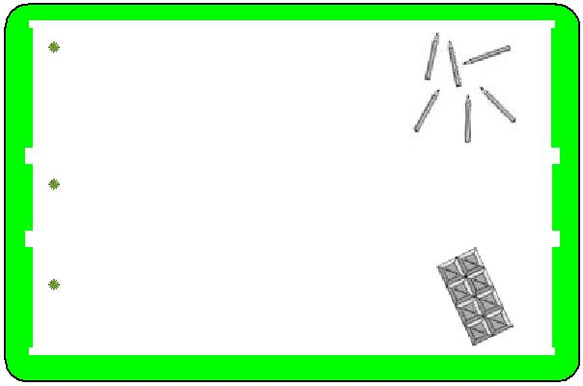

Share these pencils equally between Asif and Ben. How many pencils will each of them get.

Put half of these ten animals in the ark. How many of the animals are in the ark?

How many children can have two squares of this chocolate?

Also include:
Halves of corresponding doubles to 10

Mental strategies:
counting in twos, fives and tens; links to halving;

use arrays;

Year 2
recall and use multiplication and division facts for the

2, 5 and 10 multiplication tables, including recognising odd and even numbers

solve problems involving multiplication and division, using materials, arrays, repeated addition, mental methods, and multiplication and division facts, including problems in contexts

Pupils work with a range of materials and contexts in which multiplication and division relate to grouping and sharing discrete and continuous quantities, and relating these to fractions and measures (e.g. 40 ÷ 2 = 20, 20 is a half of 40). …

Division facts for the 2, 5 & 10 times tables

e.g. 10 ÷ 5, 30 ÷ 5, 50 ÷ 5, 20 ÷ = 4

Also include:
Halves of corresponding doubles to 20

e.g. half of 22, half of 32

Divide a two-digit number by 2, 5 or 10 to give a 'teens' answer

e.g. 70 ÷ 5, 32 ÷ 2

Mental strategies:
counting in twos, fives and tens; link to arrays;

use known facts and place value to divide; partition in different ways to divide;
links to halving;

Year 3
recall and use multiplication and division facts for the

3, 4 and 8 multiplication tables

write and calculate mathematical statements for multiplication and division using the multiplication tables that they know, including:

- two-digit numbers by one-digit numbers …using mental methods

Division facts for the 3, 4 & 8 times tables

e.g. 48 ÷ 6, 18 ÷ 6, 28 ÷ 7, 24 ÷ = 3

Divide a number by 3, 4 or 8 to give a 'teens' answer e.g. 42 ÷ 3, 68 ÷ 4, 104 ÷ 8
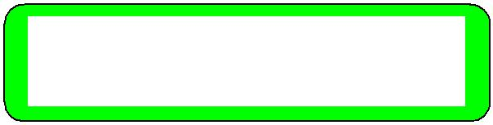

Divide a tens number by a one-digit or tens number

e.g. 60 ÷ 3, 200 ÷ 40, 320 ÷ = 40

Divide a two or three-digit number by 3, 4 or 8

e.g. 96 ÷ 3, 92 ÷ 4, 184 ÷ 8

Also include:
Halves of corresponding doubles to 50

Mental strategies:
counting in 2s, 5s, 10s, 3s, 4s and 8s;

use known facts and place value to divide by 2, 3, 4, 5 8 or 10;

SHARING
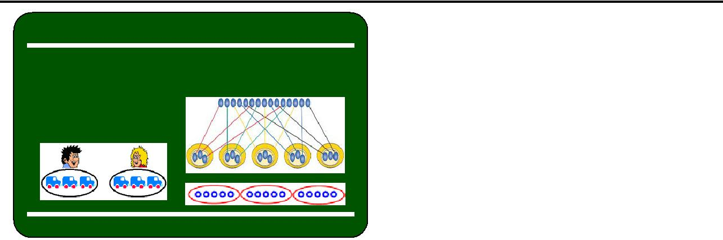
 | 6 toy cars are shared |  | 15 marbles are shared out
 |  |  | equally among 5 children.
 | between 2 children.
 | How many will they
 | have each?

GROUPING
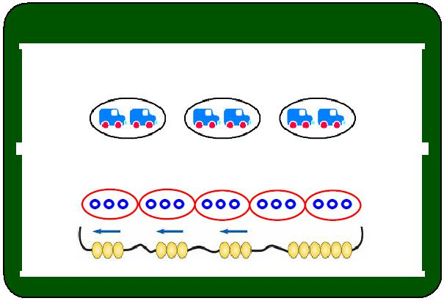
There are 6 cars; each child can have 2 cars. How many children will get 2 cars?

15 marbles put into groups of 3.

partition in different ways to divide; use halving to link ÷8, ÷4 and ÷2 tables; scaling down using known facts;

use the relationship between multiplication and division;
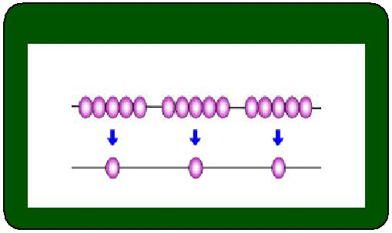
SCALING

5 times smaller

MENTAL DIVISION

Factor pairs

15 = 3 x 5, 15 has a factor pair of 3 and 5

600 ÷ 15 = 600 ÷ 3 ÷ 5

Distributive law
98 ÷ 7 = (70 ÷ 7) + (28 ÷ 7)

Link to finding fractions of amounts and quantities
Year 4
recall multiplication and division facts for multiplication tables up to 12 x 12

use place value, known and derived facts to multiply and divide mentally, including: multiplying by 0 and 1; dividing by 1; multiplying together three numbers recognise and use factor pairs and commutativity in mental calculations

Pupils practise mental methods and extend this to three-digit numbers to derive facts, (e.g. 600 ÷ 3 = 200 can be derived from 2 x 3 = 6).

Division facts for the tables to 12 x 12

e.g. 96 ÷ 12, 63 ÷ 7, 72 ÷ 6, 121 ÷ = 11
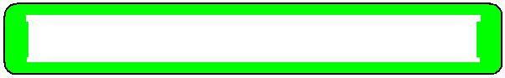

Dividing by 1

Also include:
Division linked to tables facts times a multiple of 10

e.g. 840 ÷ 70, 540 ÷ 6, 560 ÷ = 80

Division linked to tables facts times a multiple of 100

e.g. 2100 ÷ 7, 3600 ÷ 400, 8100 ÷ = 900

Divide a number to give a 'teens' answer

e.g. 105 ÷ 7, 144 ÷ 9, 96 ÷ 6

Halves of corresponding doubles of any two-digit numbers

Mental strategies:
counting in 6, 7, 9, 25 and 1000;

use partitioning and the Distributive Law to divide; use known facts and place value to divide;

use related facts to divide; use factor pairs to divide; scaling down using known facts;

use the relationship between multiplication and division;

include calculations with remainders;

Year 5
multiply and divide numbers mentally drawing upon known facts

multiply and divide whole numbers and those involving decimals by 10, 100 and 1000

They apply all the multiplication tables and related division facts frequently, commit them to memory and use them confidently to make larger calculations.

Divide a three-digit number by a one-digit

e.g. 154 ÷ 7, 138 ÷ 6, 208 ÷ 8

Divide whole numbers by 10, 100 and 1000

e.g. 32700 ÷ 10, 9600 ÷ 100, 830000 ÷ 1000

Divide decimals by 10, 100 and 1000

e.g. 32.7 ÷ 10, 251.4 ÷ 1000, 82.34 ÷ = 8.234

Also include:
Division linked to multiple of 10 times a multiple of 10

e.g. 3000 ÷ 60, 6300 ÷ 70

Halves of corresponding doubles of any multiple of 5 up to 500

Division involving remainders expressed in different ways
e.g. .98 ÷ 4 = ⁹⁸/₄ = 24 r 2 = 24½ = 24.5 ≈ 25

Mental strategies:
counting in steps of powers of 10

use partitioning and the Distributive law to divide; use known facts and place value to divide;

use related facts to divide; use factor pairs to divide; scaling down using known facts;

use the relationship between multiplication and division;

Year 6
multiply and divide numbers by 10, 100 and 1000 where the answers are up to three decimal places

Pupils continue to use all the multiplication tables to calculate mathematical statements in order to maintain their fluency.

Pupils are introduced to the division of decimal numbers by one-digit whole numbers

Division linked to tenths times a one-digit number

e.g. 3.6 ÷ 9, 4.8 ÷ = 0.6, ÷ 7 = 0.7

Division linked to hundredths number times a one-digit number

e.g. 0.18 ÷ 3, 0.27 ÷ 9, 0.56 ÷ = 0.7
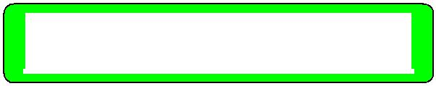

Divide numbers by 10, 100 and 1000

e.g. 0.7 ÷ 100, 25 ÷ 1000, 82.34 ÷ = 8.234

Also include:
Division linked to multiple of 10 times a multiple of 100

e.g. 42000 ÷ 600, 45000 ÷ 50

Division linked to tenths times a multiple of 10

e.g. 14 ÷ 20, 15 ÷ 0.3, 56 ÷ 70

Halves of corresponding doubles of ones and tenths and decimals less than 1 (2 d.p.)

Mental strategies:
counting in steps of powers of 10

use partitioning and the Distributive Law to divide; use known facts and place value to divide;

use related facts to divide; use factor pairs to divide; scaling down using known facts;

use the relationship between multiplication and division;

include calculations with remainders;

Main strategies for addition and subtraction

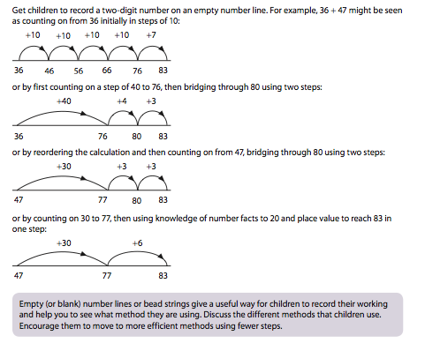
- Counting forwards and backwards

- Partitioning

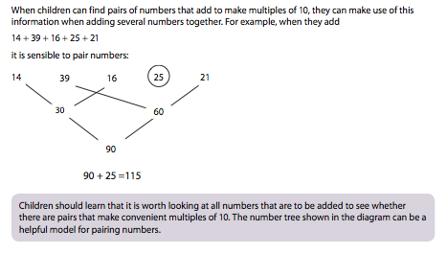
- Reordering

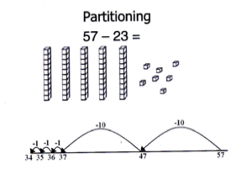

- Bridging a multiple of 10 /100

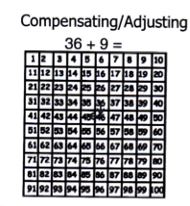
- Adjusting /
compensating

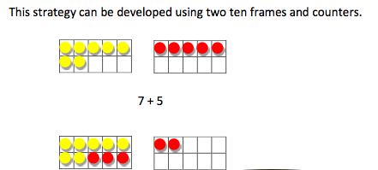

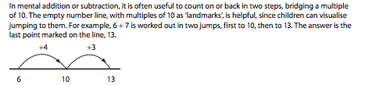

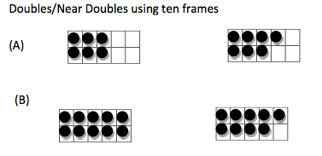
- Using ‘near’ doubles

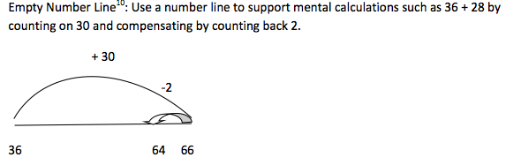

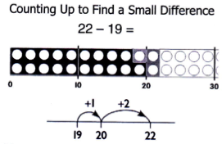

- Counting up to find a small difference

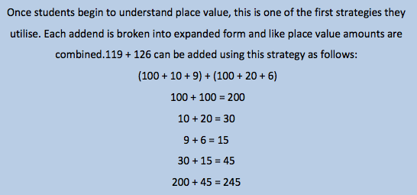
- Place value

Main strategies for multiplication and division

- Knowing multiplication and division facts to
10 × 10

- Partitioning

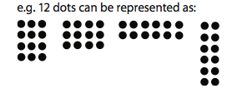

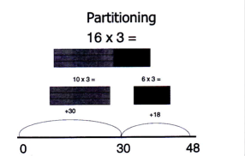

- Doubling and halving

- Multiplying and dividing by multiples of 10 & 100

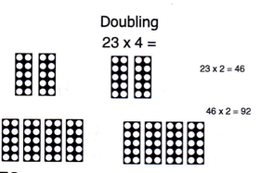

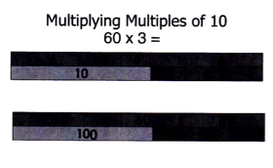

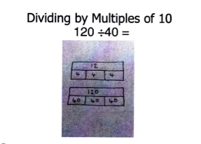

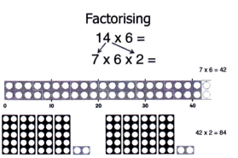
- Factorising

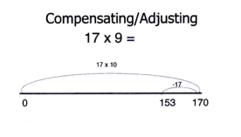
- Adjusting / compensating

