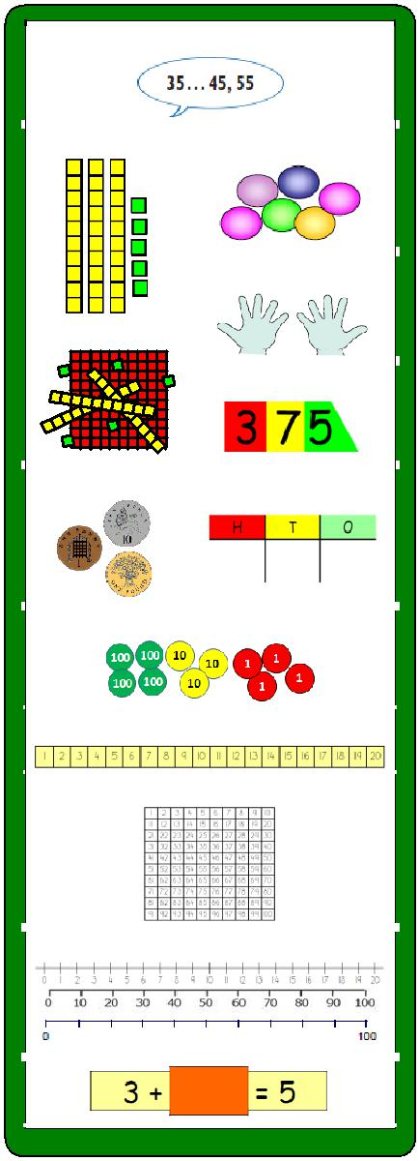
Twiss Green
Progression in
Calculations

Ask yourself:

Can I do it in my head using a mental strategy?
Could I use some jottings?
Should I use a written method?

 | Year 1 | Year 2 | Year 3 | Year 4 | Year 5 | Year 6
Addition | Combining two parts to | Adding three single | Column method- | Column method- | Column method- | Column method-
 | make a whole: part | digits. | regrouping. | regrouping. | regrouping. | regrouping.
 | whole model. | Column method – | (up to 3 digits) | (up to 4 digits) | (with more than 4 | (Decimals- with
 |  | no regrouping. |  |  | digits) | different amounts
 | Starting at the bigger |  |  |  | (Decimals- with the | of decimal places)
 | number and counting |  |  |  | same amount of
 | on. |  |  |  | decimal places)
 | Regrouping to make 10.
Subtraction | Taking away ones | Counting back | Column method | Column method | Column method | Column method
 | Counting back | Find the difference/count up | with regrouping. | with regrouping. | with regrouping. | with regrouping.
 | Find the difference/count up | Part whole model | (up to 3 digits) | (up to 4 digits) | (with more than 4 | (Decimals- with
 | Part whole model | Make 10 |  |  | digits) | different amounts
 | Make 10 | Column method- |  |  | (Decimals- with the | of decimal places)
 |  | no regrouping |  |  | same amount of
 |  |  |  |  | decimal places)
Multiplication | Doubling | Doubling | Counting in | Column | Column | Column
 | Counting in multiples | Counting in | multiples | multiplication | multiplication | multiplication
 | Arrays (with support) | multiples | Repeated addition
 |  | Repeated addition | Arrays- showing | (2 and 3 digit | (up to 4 digit | (multi digit up to 4
 |  | Arrays- showing | commutative | multiplied by 1 | numbers multiplied | digits by a 2 digit
 |  | commutative | multiplication | digit) | by 1 or 2 digits) | number)
 |  | multiplication | Grid method
Division | Sharing objects into | Division as | Division within | Division within | Short division | Short division
 | groups | grouping | arrays | arrays |  | Long division
 | Division as grouping | Division within | Division with a | Division with a | (up to 4 digits by a | (up to 4 digits by a
 |  | arrays | remainder | remainder | 1 digit number | 2 digit number-
 |  |  | Short division (2 | Short division (up | interpret | interpret
 |  |  | digits by 1 digit- | to 3 digits by 1 | remainders | remainders as
 |  |  | concrete and | digit- concrete and | appropriately for | whole numbers,
 |  |  | pictorial) | pictorial) | the context) | fractions or round)

Addition

Objective and | Concrete | Pictorial | Abstract
Strategies

Combining two |  |  |  |  |  |  |  |  | 4 + 3 = 7
parts to make
a whole: part- |  |  |  |  |  |  |  |  | 10= 6 + 4
whole model
 |  | Use cubes to add |  |  |  |  |  |  |  |  | 5
 |  | two numbers
 |  | together as a |  |  | Use pictures to
 |  | group or in a bar. |  |  | add two numbers |  |  |  |  |  | 3
 |  |  |  |  | together as a
 |  |  |  |  | group or in a bar. |  |  |  |  | Use the part-part
 |  |  |  |  |  |  |  |  |  | whole diagram as
 |  |  |  |  |  |  |  |  |  | shown above to
 |  |  |  | 8 |  | 1
 |  |  |  |  |  |  |  |  |  | move into the
 |  |  |  |  |  |  |  |  |  | abstract.
Starting at the | 12 + 5 = 17 |  |  |  |  |  |  |  | 5 + 12 = 17
bigger number
and counting
on | Start with the larger number on the
 | bead string and then count on to the
 | smaller number 1 by 1 to find the
 | answer. |  |  |  |  |  |  |  | Place the larger number in
 |  |  | Start at the larger number on the number line and count
 |  |  |  |  |  |  |  |  | your head and count on the
 |  |  | on in ones or in one jump to find the answer.
 |  |  |  |  |  |  |  |  | smaller number to find your
 |  |  |  |  |  |  |  |  | answer.
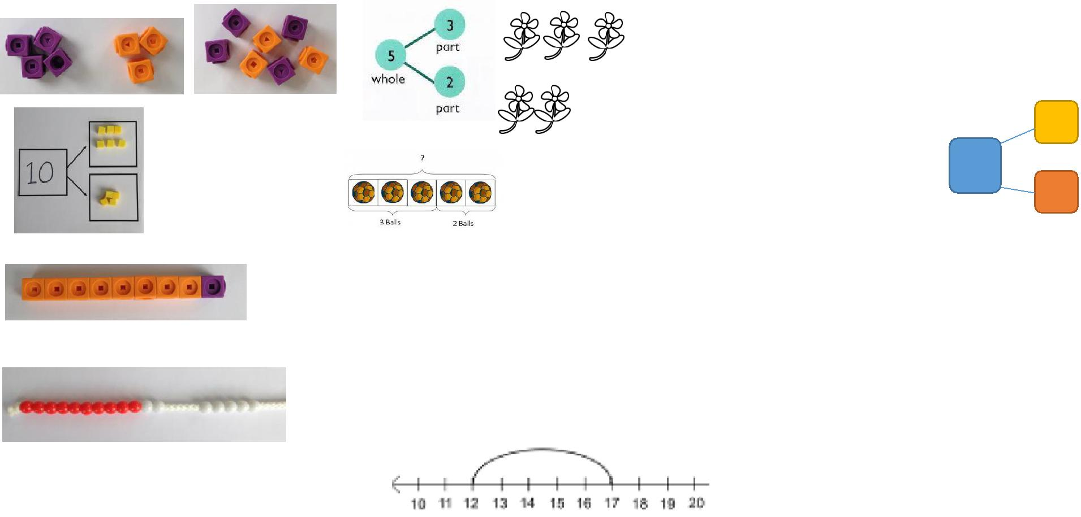
 |  |  |  |  |  |  |  | 7 + 4= 11
 |  |  |  |  | Use pictures or a
Regrouping to |  |  |  |  | number line. Regroup |  |  | If I am at seven, how many
make 10. |  |  |  |  | or partition the smaller |  |  | more do I need to make 10.
 |  |  |  |  | number to make 10. |  |  | How many more do I add on
 | 6 + 5 = 11 |  |  |  |  |  |  | now?
 | Start with the
 | bigger number
 | and use the
 | smaller number to
 | make 10.
Adding three | 4 + 7 + 6= 17 | + |  | +
single digits | Put 4 and 6 together to make 10. Add
 | on 7.
 |  |  |  | + |  |  |  | Combine the two numbers
 |  |  |  |  |  |  |  | that make 10 and then add
 |  |  |  |  |  |  |  | on the remainder.
 | Following on from making 10, make 10
 |  |  | Add together three groups of objects. Draw a
 | with 2 of the digits (if possible) then add
 |  |  | picture to recombine the groups to make 10.
 | on the third digit.
Column | 24 + 15= | After practically using the base 10 blocks and place value
method- no | Add together the ones first then add the | counters, children can draw the counters to help them to
 | tens. Use the Base 10 blocks first before | solve additions.
regrouping | moving onto place value counters. |  | T |  | O
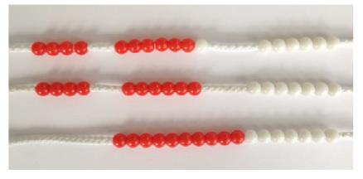
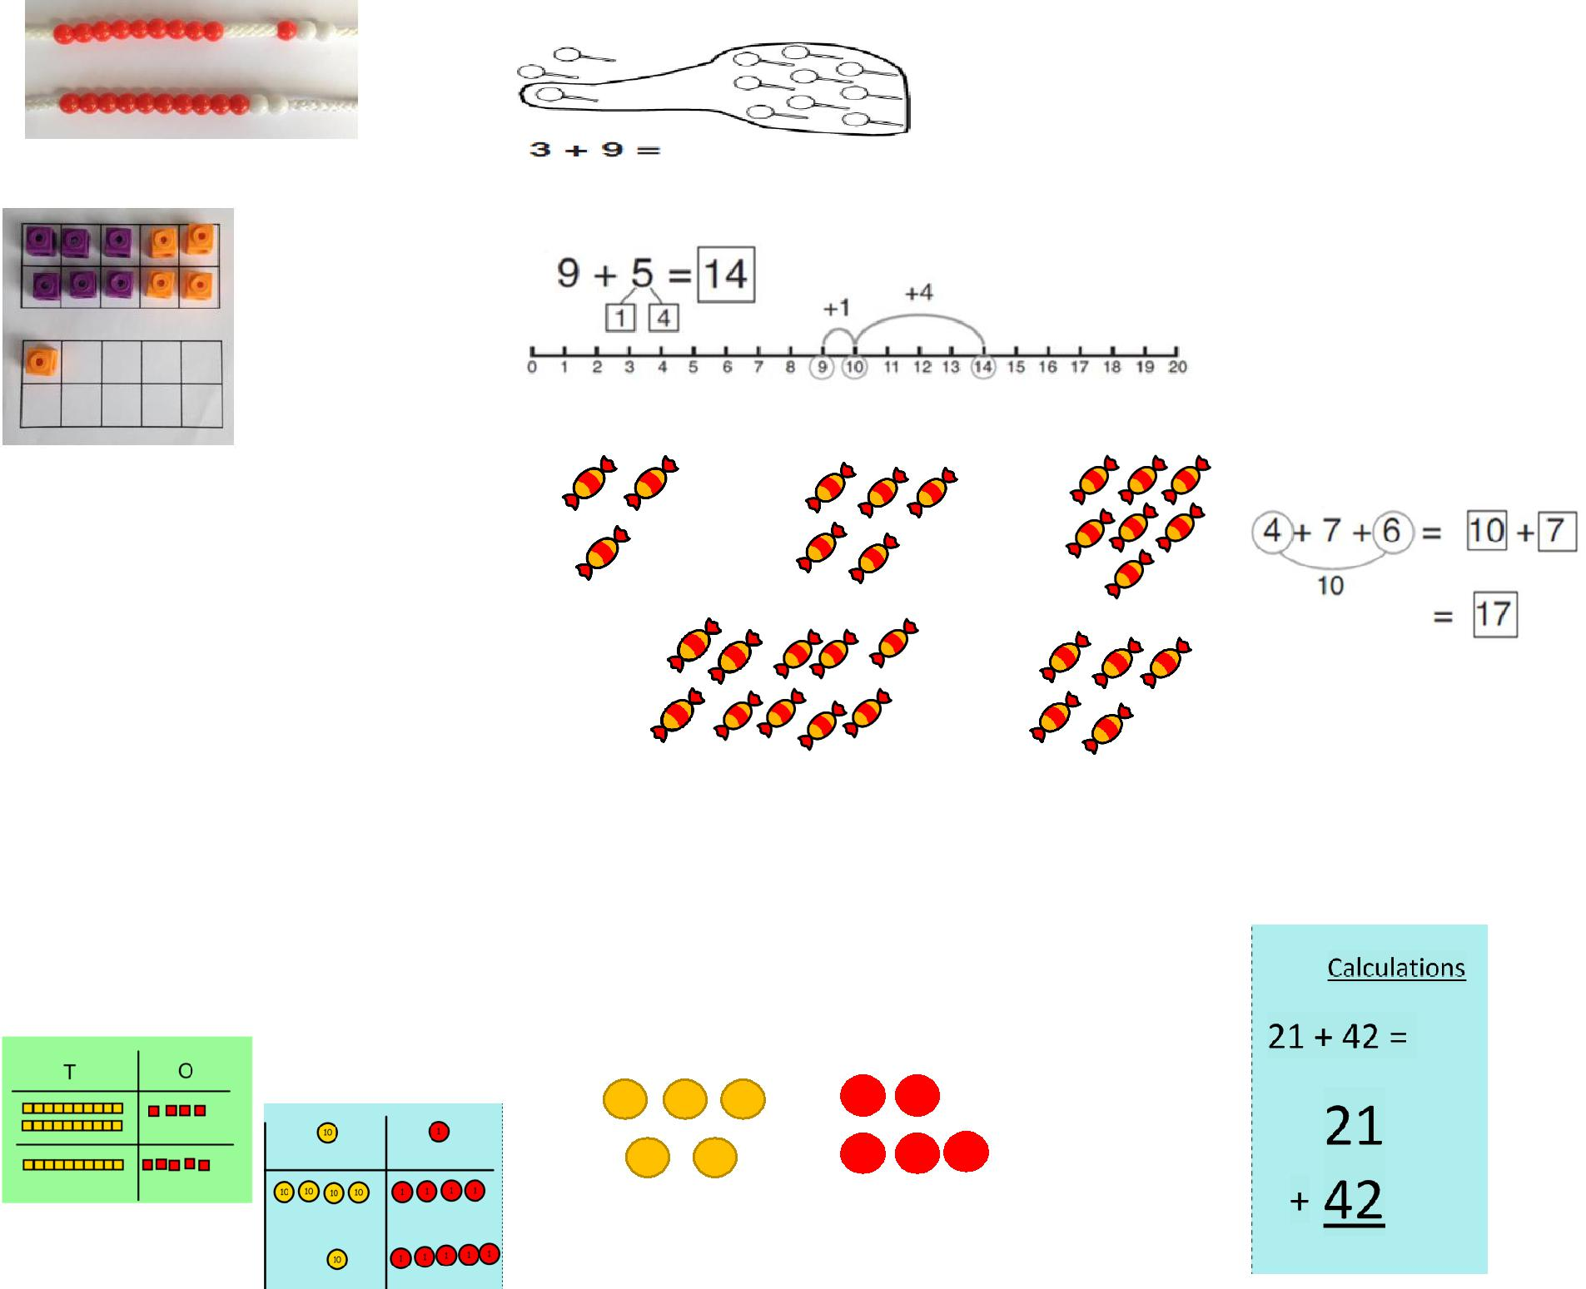

Column method-regrouping
Use the Base 10 blocks first before moving onto place value counters.
Make both numbers on a place value grid.

Add up the units and exchange 10 ones for one 10.
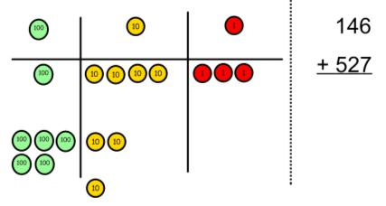

Add up the rest of the columns, exchanging the 10 counters from one column for the next place value column until every column has been added.

This can also be done with Base 10 to help children clearly see that 10 ones equal 1 ten and 10 tens equal 100.

As children move on to decimals, money and decimal place value counters can be used to support learning.
Children can draw a pictoral representation of the columns and place value counters to further support their learning and understanding.
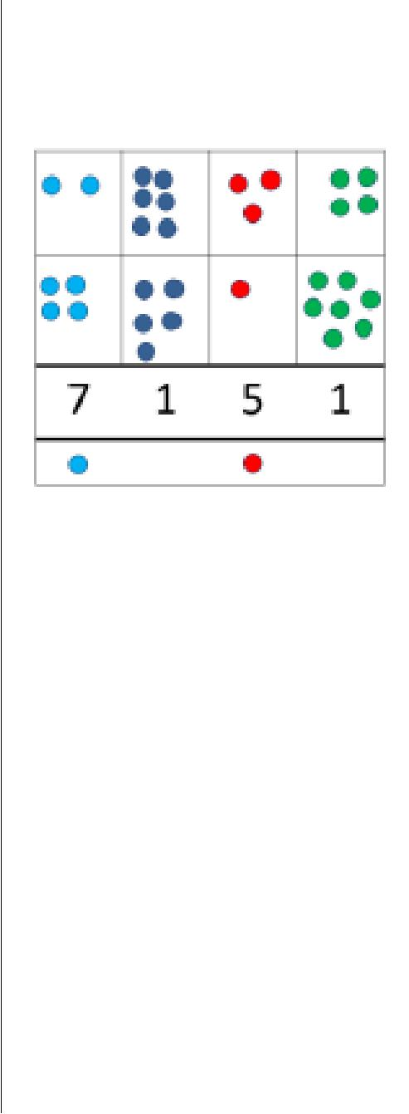
Start by partitioning the numbers before moving on to clearly show the exchange below the addition.
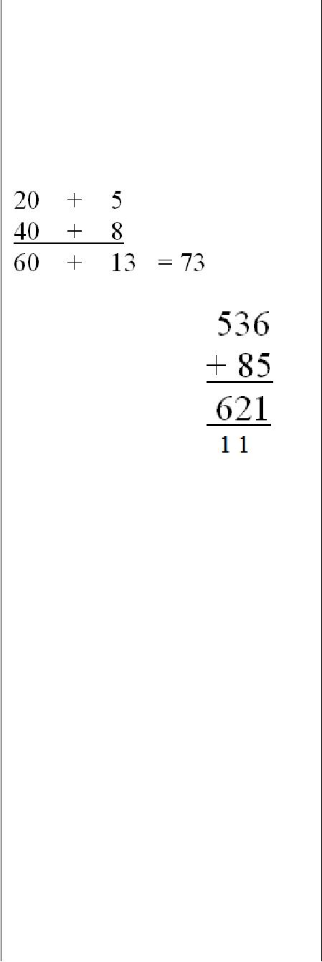

As the children move on, introduce decimals with

the same number of decimal places and different. Money can be used here.
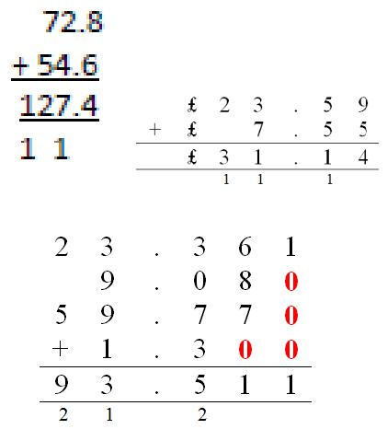
Subtraction

Objective and | Concrete | Pictorial | Abstract
Strategies
Taking away | Use physical objects, counters, cubes | Cross out drawn objects to show what has been taken | 18 -3= 15
ones |  | away.
 | etc to show how objects can be taken |  | 8 – 2 = 6
 | away.
 | 6 – 2 = 4

Counting back | Make the larger number in your | Count back on a number line or number track | Put 13 in your head, count
 | subtraction. Move the beads along your |  | back 4. What number are
 | bead string as you count backwards in |  | you at? Use your fingers to
 | ones. |  | help.
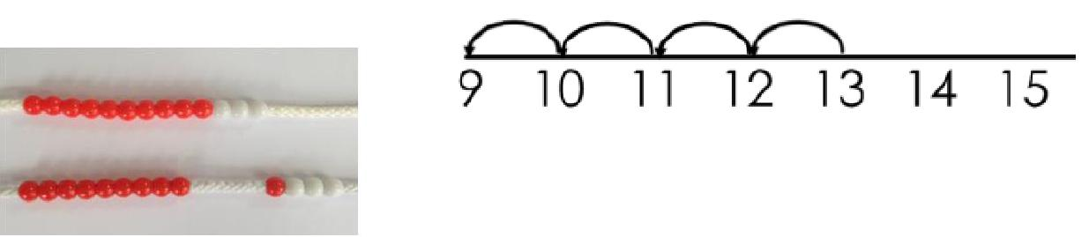

13 – 4
Start at the bigger number and count back the smaller number showing the jumps on the number line.

Use counters and move them away from the group as you take them away counting backwards as you go.
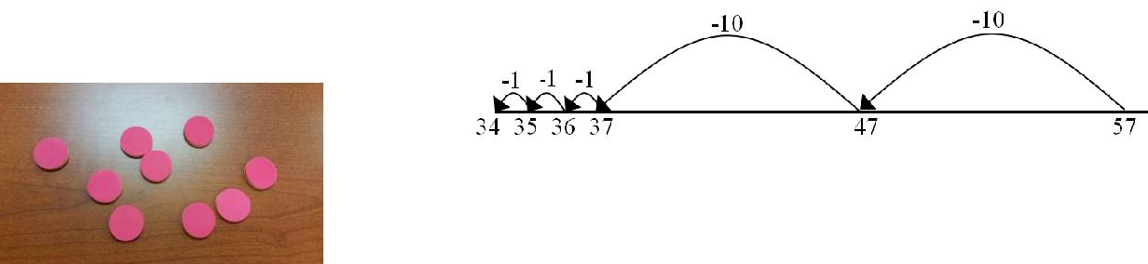

This can progress all the way to counting back using two 2 digit numbers.

Find the | Compare amounts and objects to find | Count on to | Hannah has 23 sandwiches,
difference | the difference. |  | Helen has 15 sandwiches.
 |  | find the | Find the difference between
 |  | difference. | the number of sandwiches.
 | Use cubes to
 | build towers or
 | make bars to
 | find the
 | difference
 |  | Draw bars to
 | Use basic bar | find
 | models with | the difference
 | items to find | between 2
 | the difference | numbers.
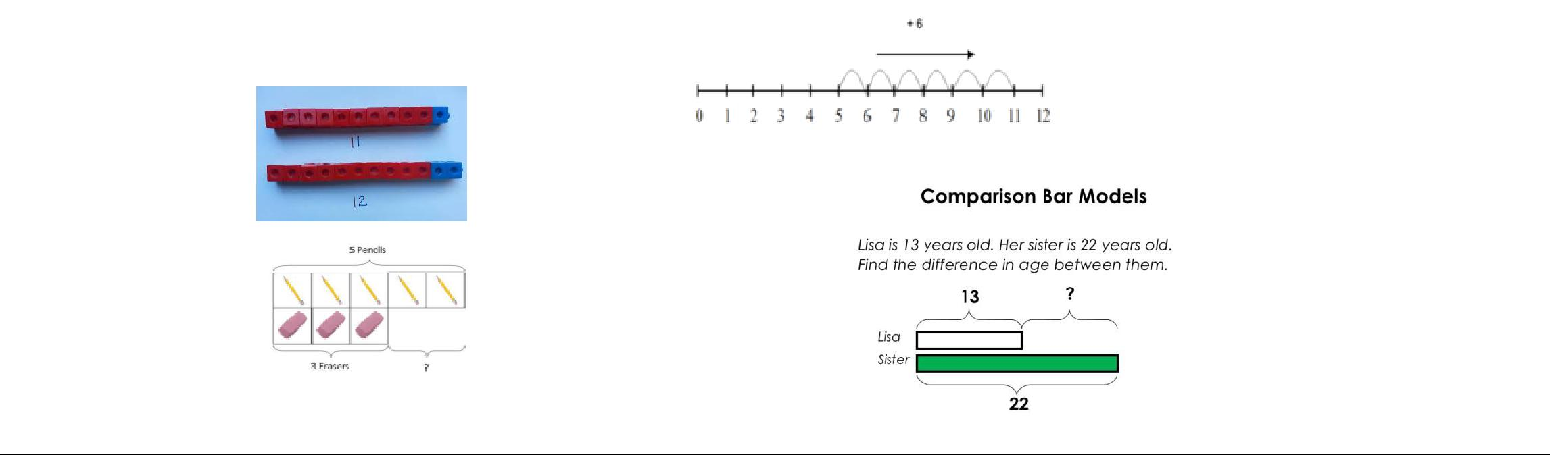

Part Part | Link to addition- use | Use a pictorial representation of objects to show the part | 5
Whole Model | the part whole model | part whole model.
 | to help explain the
 | inverse between |  | 10
 | addition and
 | subtraction.
 | If 10 is the whole and 6 is one of the |  | Move to using numbers
 | parts. What is the other part? |  | within the part whole model.
 | 10 - 6 =
Make 10 | 14 – 9 = |  | 16 – 8=
 |  |  | How many do we take off to
 |  |  | reach the next 10?
 |  | Start at 13. Take away 3 to reach 10. Then take away the | How many do we have left
 | Make 14 on the ten frame. Take away | remaining 4 so you have taken away 7 altogether. You
 |  |  | to take off?
 | the four first to make 10 and then | have reached your answer.
 | takeaway one more so you have taken
 | away 5. You are left with the answer of
 | 9.
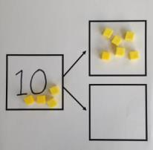
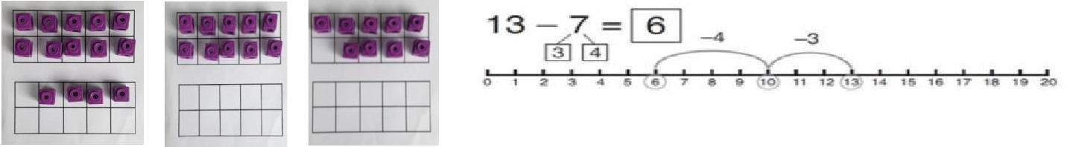
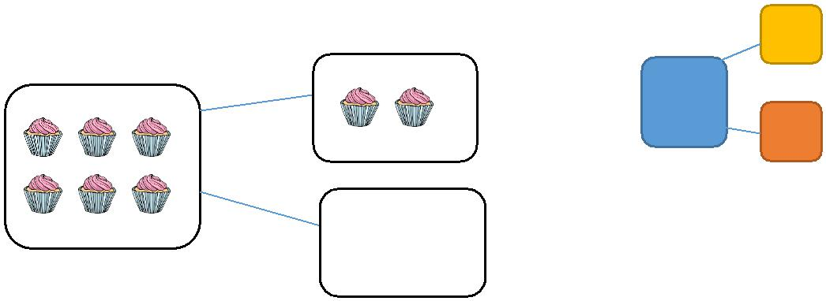

Column | Use Base 10 | Draw the Base
method | to make the | 10 or place
 | bigger | value counters
without | number then | alongside the
regrouping | take the | written
 | smaller | calculation to
 | number | help to show | Use ARROWS not + sign
 | away. | working.
 | Show how |  | This will lead to a clear
 |  |  | written column subtraction.
 | you partition
 | numbers to
 | subtract.
 | Again make
 | the larger
 | number first.
Column | Use Base 10 to start with before moving | Draw the counters onto
method with | on to place value counters. Start with
 | one exchange before moving onto | a place value grid and
regrouping | subtractions with 2 exchanges. | show what you have
 |  | taken away by crossing
 | Make the larger number with the place | the counters out as well
 | value counters | as clearly showing the
 |  | exchanges you make. | Children can start their
 |  |  | formal written method by
 |  |  | partitioning the number into
 |  |  | clear place value columns.
 |  | When confident, children can | Use ARROWS
 | Start with the ones, can I take away 8 | find their own way to record
 |  | the exchange/regrouping.
 | from 4 easily? I need to exchange one
 | of my tens for ten ones. | Just writing the numbers as
 |  | shown here shows that the
 |  | child understands the method
 |  | and knows when to exchange/regroup.
 |  |  | Moving forward the children
 |  |  | use a more compact
 |  |  | method.
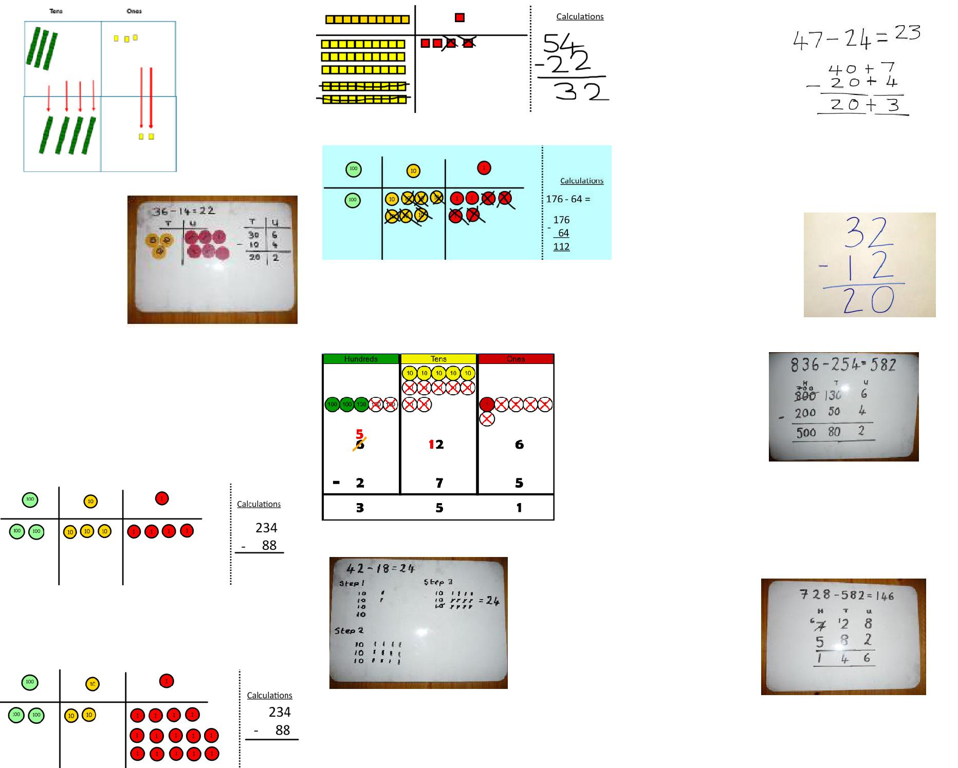

Now I can subtract my ones.
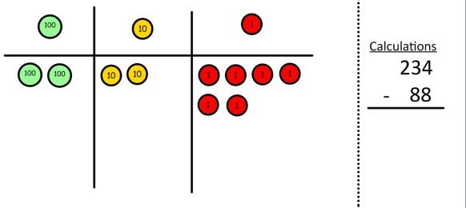

Now look at the tens, can I take away 8 tens easily? I need to exchange one hundred for ten tens.
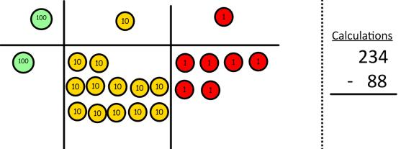

Now I can take away eight tens and complete my subtraction
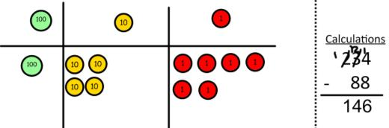

Show children how the concrete method links to the written method alongside your working. Cross out the numbers when exchanging and show where we write our new amount.
This will lead to an understanding of subtracting any number including decimals.
Multiplication

Objective and | Concrete | Pictorial | Abstract
Strategies
Doubling | Use practical activities to show how to | Draw pictures to show how to double a number.
 | double a number.
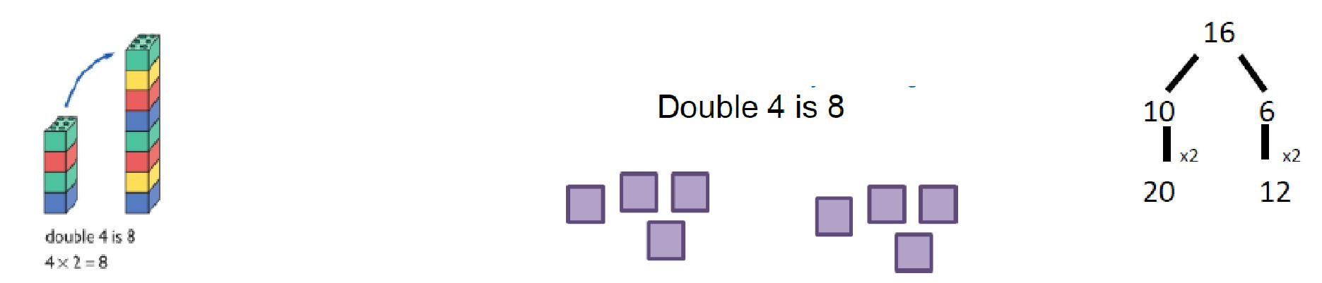

 | Partition a number and then
 | double each part before
 | recombining it back
 | together.
Counting in | Count in multiples of a
multiples | number aloud.
 | Write sequences with
 | multiples of numbers.
 | 2, 4, 6, 8, 10
 | 5, 10, 15, 20, 25 , 30
 | Use a number line or pictures to continue support in
 | counting in multiples.
 | Count in multiples supported by
 | concrete objects in equal groups.
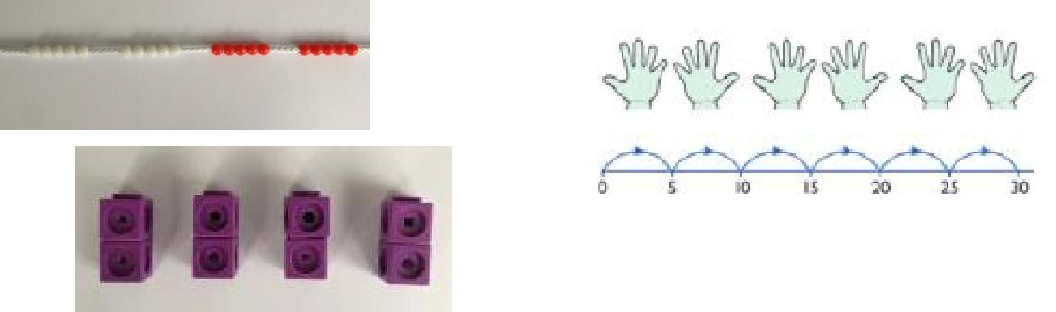
Repeated
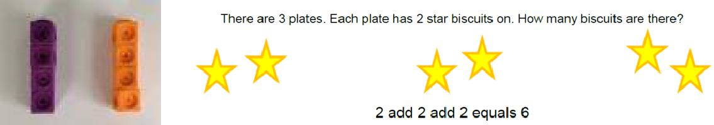
Write addition sentences to addition describe objects and
pictures.
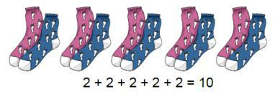
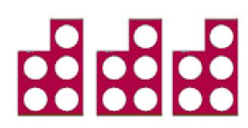

 |  | Use different
 |  | objects to add
 |  | equal groups.
Arrays- | Create arrays using counters/ cubes to |  | Draw arrays in different rotations | Use an array to write
showing | show multiplication sentences. |  | to find commutative | multiplication sentences and
 |  |  | multiplication sentences. | reinforce repeated addition.
commutative
multiplication
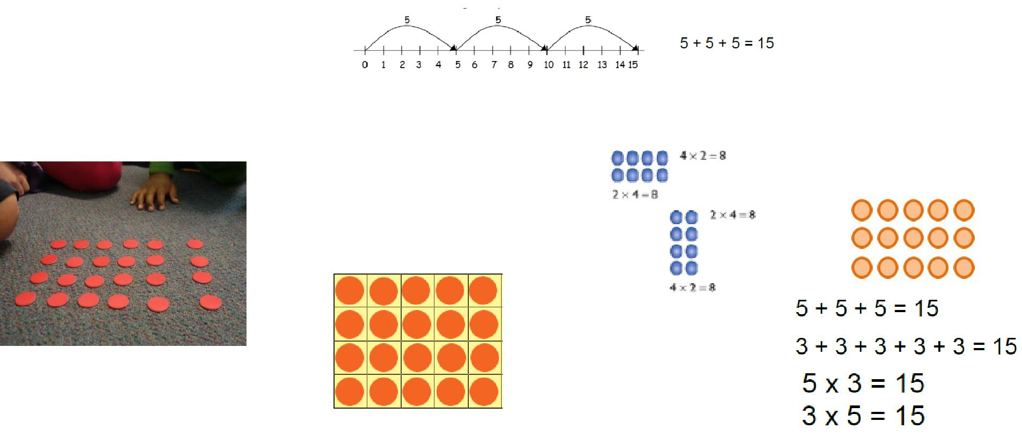

Link arrays to area of rectangles.
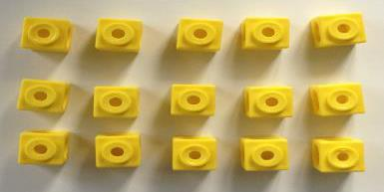
Grid Method | Show the link with arrays to first
 | introduce the grid method.
 | 4 rows
 | of 10
 | 4 rows
 | of 3
 | Move on to using Base 10 to move
 | towards a more compact method.
 | 4 rows of 13
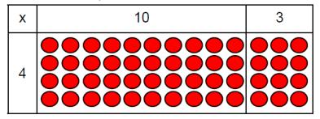
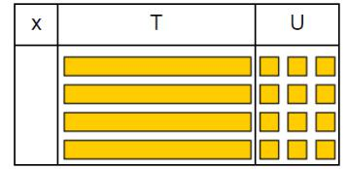

Move on to place value counters to show how we are finding groups of a number.We are multiplying by 4 so we need 4 rows.
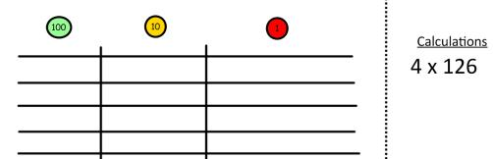

Fill each row with 126.
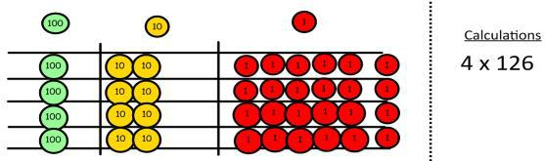

Add up each column, starting with the ones making any exchanges needed.
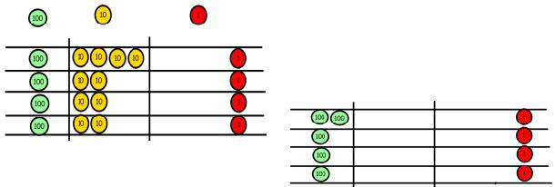

Then you have your answer.

Children can represent the work they have done with place value counters in a way that they understand.

They can draw the counters, using colours to show different amounts or just use circles in the different columns to show their thinking as shown below.
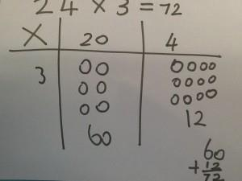
Start with multiplying by one digit numbers and showing the clear addition alongside the grid.

Moving forward, multiply by a 2 digit number showing the different rows within the grid method.
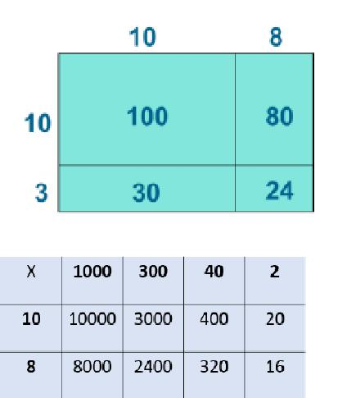

Column multiplication
Children can continue to be supported by place value counters at the stage of multiplication.

It is important at this stage that they always multiply the ones first and note down their answer followed by the tens which they note below.
Bar modelling and number lines can support learners when solving problems with multiplication alongside the formal written methods.
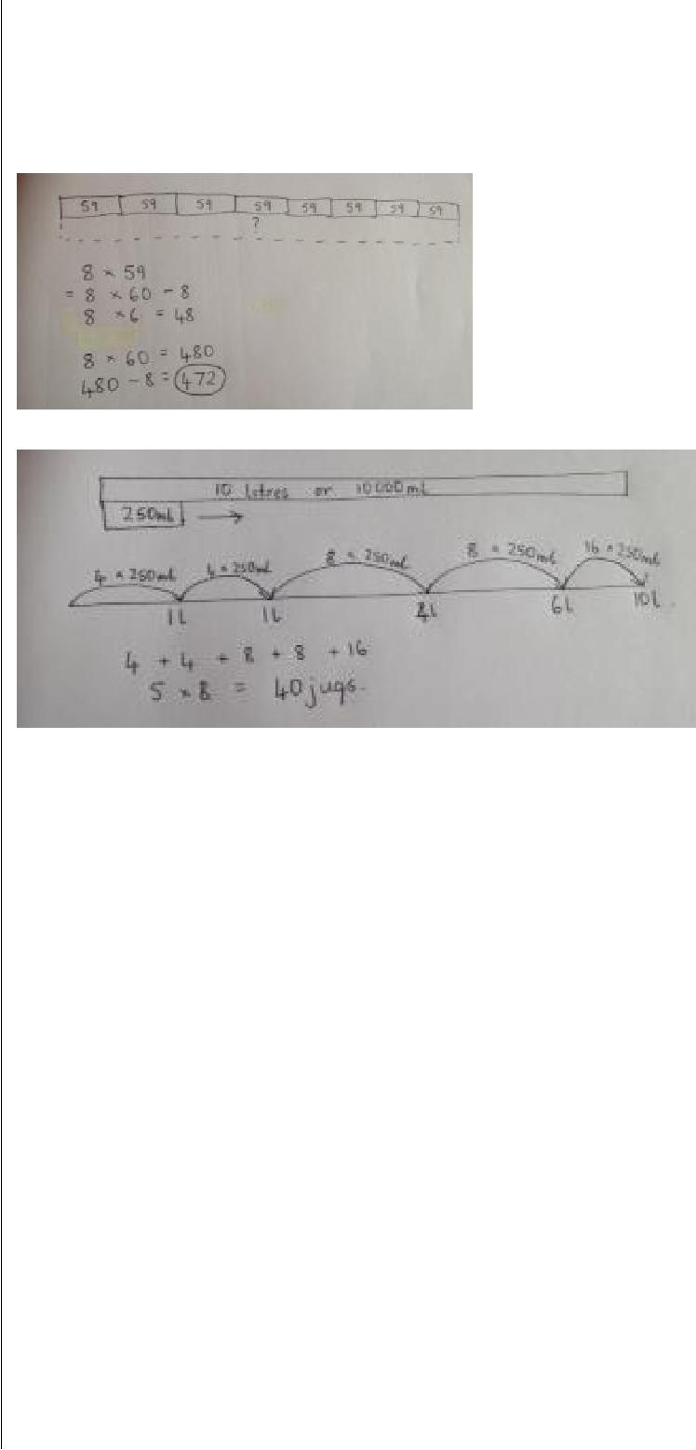
Start with short then long multiplication, reminding the children about lining up their numbers clearly in columns.
654 leads to 654
x 7 x 7
28 4578
350 4 3 2
4200
4578

If it helps, children can write out what they are solving next to their answer.

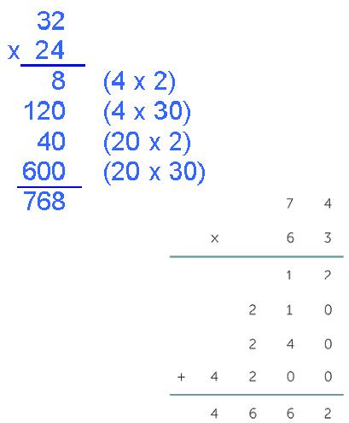

This moves to the more compact method.
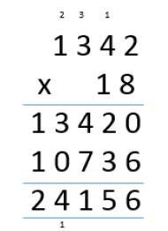
Division

Objective and | Concrete |  | Pictorial |  | Abstract
Strategies
Sharing |  | Children use pictures or shapes to share quantities. |  |  | Share 9 buns between three
objects into |  |  |  |  | people.
groups |  |  |  |  | 9 ÷ 3 = 3
 | I have 10
 | cubes, can you
 | share them
 | equally in 2 |  | 8 ÷ 2 = 4
 | groups?
Division as | Divide quantities into equal groups. | Use a number line to show jumps in groups. The number |  |  | 28 ÷ 7 = 4
grouping
 | Use cubes, counters, objects or place | of jumps equals the number of groups.
 | value counters to aid understanding. |  |  |  | Divide 28 into 7 groups.
 |  |  |  |  | How many are in each
 |  |  |  |  | group?
 |  | Think of the bar as a whole. Split it into the number of
 |  | groups you are dividing by and work out how many would
 |  | be within each group.
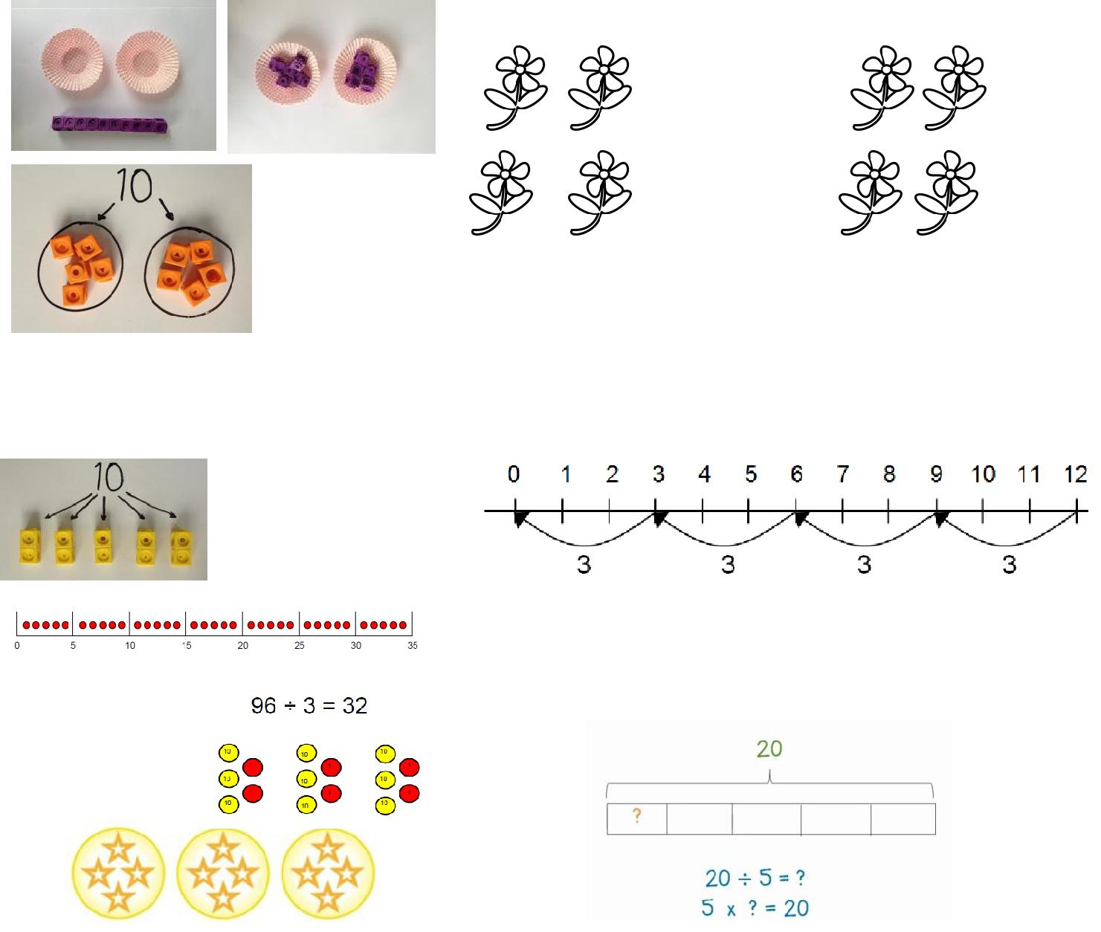

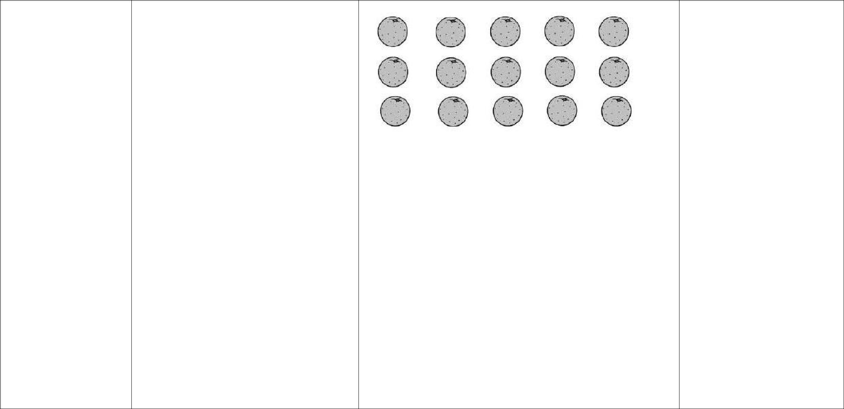  Division within |  | Link division |  |  |  |  | Find the inverse of
arrays |  |  |  |  |  |  | multiplication and division
 |  | to |  |  |  |  | sentences by creating four
 |  | multiplication |  |  |  |  | linking number sentences.
 |  | by creating
 |  | an array and |  |  |  |  | 7 x 4 = 28
 |  | thinking |  |  |  |  | 4 x 7 = 28
 |  | about the |  |  |  |  | 28 ÷ 7 = 4
 | number sentences that can be created. |  |  |  |  |  | 28 ÷ 4 = 7
 | Eg 15 ÷ 3 = 5 | 5 x 3 = 15 | Draw an array and use lines to split the array into groups
 | 15 ÷ 5 = 3 | 3 x 5 = 15 |  | to make multiplication and division sentences.
Division with a | 14 ÷ 3 = |  | Jump forward in equal jumps on a number line then see |  |  |  | Complete written divisions
remainder | Divide objects between groups and |  | how many more you need to jump to find a remainder. |  |  |  | and show the remainder
 | see how much is left over |  |  |  |  |  | using r.
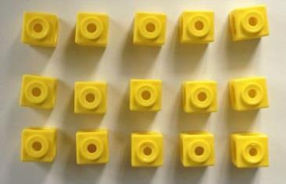
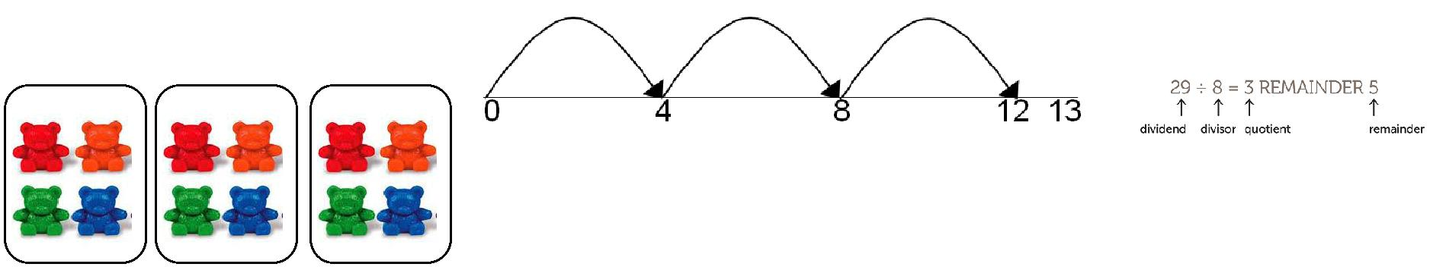

Draw dots and group them to divide an amount and clearly show a remainder.
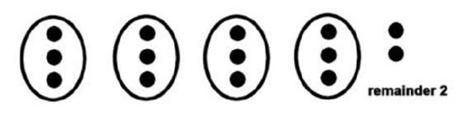
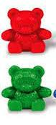
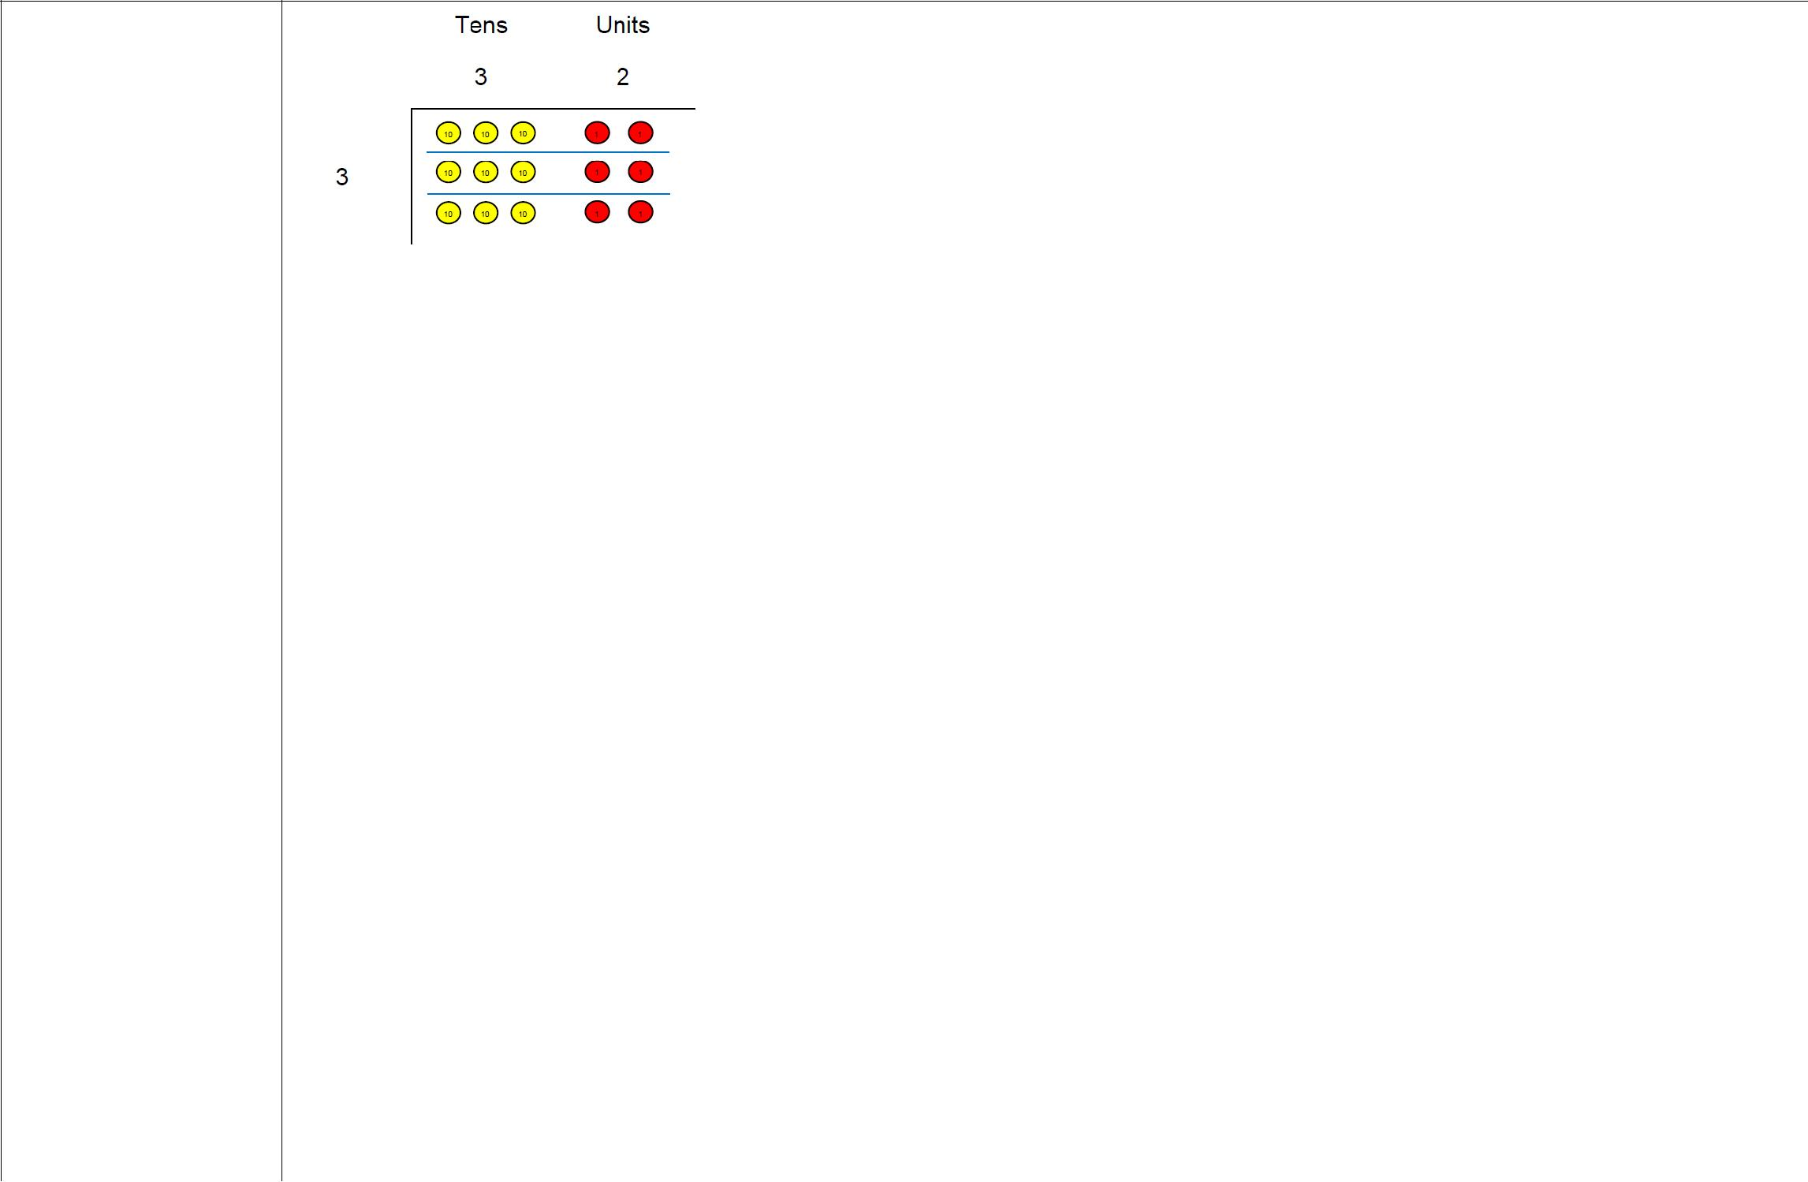
Short division

Use place value counters to divide using the bus stop method alongside
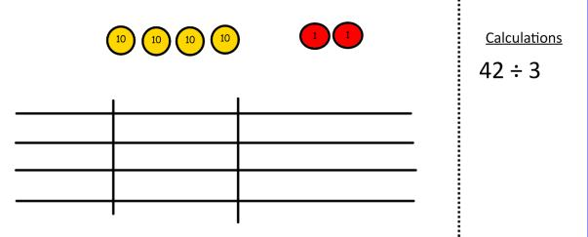

42 ÷ 3=

Start with the biggest place value, we are sharing 40 into three groups. We can put 1 ten in each group and we have 1 ten left over.
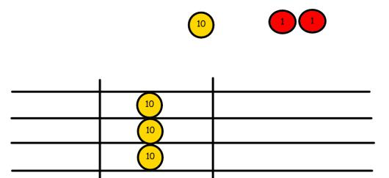

We exchange this ten for ten ones and then share the ones equally among the groups.
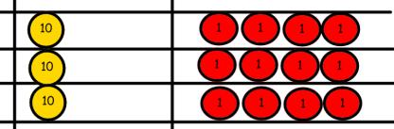

We look how much in 1 group so the answer is 14.

Students can continue to use drawn diagrams with dots or circles to help them divide numbers into equal groups.

Encourage them to move towards counting in multiples to divide more efficiently.

Begin with divisions that divide equally with no remainder.

Move onto divisions with a remainder.
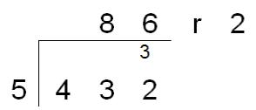

Finally move into decimal places to divide the total accurately.
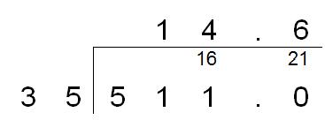
Long division | 2544 ÷ 12
 | How many groups of 12
 | thousands do we have?
 | None
 | Exchange 2 thousand for 20 hundreds.
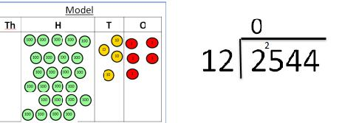

How many groups of 12 hundreds are in 25 hundreds? 2 groups. Circle them.

We have grouped 24 hundreds so can take them off and we are left with one.
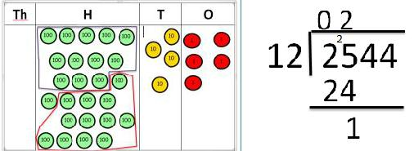

Exchange the one hundred for ten tens so now we have 14 tens. How many groups of 12 tens are in 14? 1 remainder 2
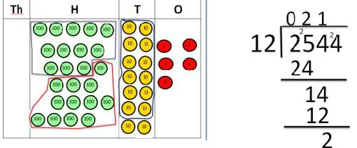

Exchange the two tens for twenty ones so now we have 24 ones. How many groups of 12 are in 24? 2
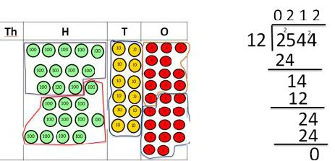
Instead of using physical counters, students can draw the counters and circle the groups on a whiteboard or in their books.
Use this method to explain what is happening and as soon as they have understood what move on to the abstract method as this can be a time consuming process.

